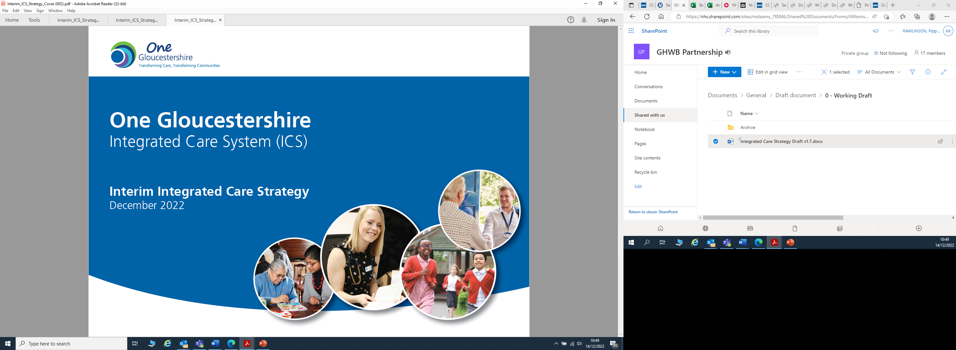

# **Foreword**

By working together, we can make Gloucestershire the healthiest place to live and work, championing equity in life chances and the best health and care outcomes for all.

Under the Health and Care Act 2022 the Gloucestershire Integrated Care System was formalised into a legal entity with a newly established **‘One Gloucestershire Health & Wellbeing Partnership’**. This presents a golden opportunity to build on our commitment to partnership working to make a real difference to the health, care and wellbeing of people who live or work in Gloucestershire. We have a long history of good working relationships in our county, and we intend to take this opportunity to go further and draw on the assets of all our partners including our communities to ensure people in Gloucestershire can live happy and healthy lives. ​

We serve a population of over 660,000 people across urban and rural areas and enjoy relatively good health overall in the county. Average life expectancy at birth is 80 years for males and 84 years for females[1], which is above the England average. On average, people in Gloucestershire enjoy 67 years in good health. However, these figures mask significant, unfair and systematic differences in health and wellbeing between different groups of people. People living in the wealthiest areas of the county experience on average 11 years longer of ‘healthy life’ compared with those in the least wealthy areas. Such differences are unacceptable and avoidable, and by working together we can drive forward improvements in population health and create equity for all.

This interim Integrated Care Strategy has been developed by the One Gloucestershire Health & Wellbeing Partnership, based upon engagement with the public and in discussion with wider stakeholders across Gloucestershire. It is recognised nationally that 2022 and 2023 will be a transition period for health and care systems. Therefore, this is an interim strategy reflecting the need for it to be refreshed as the One Gloucestershire Health and Wellbeing Partnership develops and matures. Within this version, we build on the great work already in place across our county, whilst recognising that working in a formalised partnership challenges us to go further with our ambitions. We are required to write a 5-year Integrated Care Strategy, but we want to go beyond this, to set the direction for the next 10-20 years with a commitment to continue to evolve and develop this strategy as our partnership grows and we learn from each other.

As a system we have increasingly worked together to improve how we use our resources, however the environment we now face is much more challenging. In common with other parts of the country we face very significant financial headwinds, as we respond to the ongoing impacts on our population and workforce of the COVID-19 pandemic and cost of living situation. These pressures exist on top of the financially challenged position we faced prior to the pandemic. In response we are working together to look at how we are spending our money and whether we are delivering best value and outcomes for our population. Despite these substantial challenges we are committed to creating the best value for the ‘Gloucestershire pound’ and delivering the changes our population want.

This strategy is our One Gloucestershire Health & Wellbeing Partnership blueprint for delivering better health and care with and for the people of Gloucestershire. Building on existing strategies and partnerships, there is a clear focus on prevention, ensuring independence, resilience and equity through working in collaboration with our communities. It builds upon the current Health and Wellbeing Strategy and re-affirms our local vision for integrated health and care, setting ambitious goals for our local system and improved health outcomes for local people. We will drive and enhance integrated approaches and collaborative working at every level - where these can improve planning, service delivery and outcomes.

This document is designed to guide our health and care organisations, staff, voluntary and community sector, and our people and communities, to work together to achieve the common goal of better health and wellbeing for our population. It sets out how we are already working together to make transformational changes in health, care and wellbeing; and details our ambitions for the future.

**Cllr Carole Allaway**-**Martin**

Cabinet Member for Adult Social Care Commissioning. Chair of One Gloucestershire Health and Wellbeing Partnership

# **1. Introduction**

From 1 July 2022, the One Gloucestershire Integrated Care System became a legal entity, progressing our existing partnership which brings together NHS, social care, public health and other public, voluntary and community sector organisations to build a healthier Gloucestershire. We know that by working together we can support and enable people to live well and provide high-quality joined-up care when people need it.

### *Box 1: The audience for the Interim Integrated Care Strategy*

This interim Integrated Care Strategy has been created by and for health, care, and wellbeing partner organisations across Gloucestershire. The purpose of this interim version of the Integrated Care Strategy is to support strategic alignment across the county, thereby allowing partners to identify further opportunities to work together to make Gloucestershire the healthiest place to live and work, championing equity in life chances and the best health and care outcomes for all.

A further version of this strategy, with the people of Gloucestershire as the intended audience, will be produced during 2023 as part of an iterative process of review and engagement.

We have been an Integrated Care System since 2018 and already have a well-developed approach to working together with examples of joint commissioning, shared delivery and aligned budgets. As a system, we have worked well to progress new integrated care models for our patients and have prioritised developing positive relationships, building trust, and engaging with and enabling communities and individuals. Across Gloucestershire we have strong Primary Care Networks and Integrated Locality Partnerships (see section 7.1), supported by integrated teams who are improving patient access and experience, delivering outcomes which enhance wellbeing and independence, and improving health equity.

This interim Integrated Care Strategy identifies the good work already underway in the county and reconfirms our direction of travel over the coming years, including our ambitions as a system. One Gloucestershire Health and Wellbeing Partnership has only had a short time together and therefore as the partnership grows, we commit to further developing our Integrated Care Strategy through 2023, with the intention of developing a social contract with partners and the public. We believe this should be an iterative process that will deliver discernible change and therefore the Integrated Care Strategy should be a live document that remains responsive to the challenges and opportunities that arise over the coming years. As such, whilst this strategy seeks to set the direction for the next 10-20 years, there will be a regular process of review and exploration to ensure it continues to pave the way for partners, communities and individuals to work collaboratively to achieve the best health, care and wellbeing for all.

Over the last few years, health and care systems have faced additional challenges which have tested their resilience and ability to respond (box 2).

### *Box 2: Recent system wide challenges*

|  |  |  |  |
| --- | --- | --- | --- |
| **COVID-19**  The COVID-19 pandemic tested health and care services globally and shone a light on health inequalities. It quickly became evident that the interconnections between factors such as race, gender and geography were associated with an increased risk of becoming ill or dying with a disease such as COVID-19. Whilst the pandemic tested our resilience it also demonstrated the strength of our communities in supporting health and wellbeing. | **Cost of living**  The UK cost-of-living rise began in late 2021 and continues to escalate. This period has seen a fall in “real” disposable incomes. It affects all households to some extent, but the Economic Observatory reports that “it is disproportionately affecting poorer households. With fewer resources to cover rising bills, many are taking on debt just to get by”. These financial pressures present a significant risk to the physical and mental health and wellbeing of the local population, particularly among the more vulnerable. | **Emerging health protection threats**  Since COVID-19, there have continued to be emerging infectious disease threats such as Monkeypox. Since May 2022, cases have been reported in multiple countries that do not usually have Monkeypox, including the UK. While usually self-limiting, severe illness can occur in some individuals. Vaccination is being offered to protect individuals at higher risk of exposure and reduce the spread of disease. In Gloucestershire this is being delivered by the Specialist Sexual Health service. | **Global displacement**  The number of people forced to flee their homes has increased every year over the past decade and stands at the highest level since records began (UNHCR’s annual Global Trends report, 2021). A number of asylum and migration schemes are in place to support the resettlement of individuals displaced by global events and nearly 2,700 individuals have arrived in Gloucestershire through such scheme, including 1302, people via the UK’s new ‘Homes for Ukraine’ scheme. |

There are also some key long-term challenges facing our system, which include:

* **An ageing and growing population with evolving healthcare needs**, such as the increase in the prevalence of obesity and diabetes, or antibiotic resistance.
* **Medical advancements** that save lots of lives every year but push up annual costs to the NHS by an estimated additional £10bn a year.
* **Workforce recruitment and retention** challenges are increasing across the system with high levels of vacancies, leading to heavier demands on the workforce and a corresponding impact on the quality of care.
* **Financial challenges** as we respond to the ongoing impacts of the COVID-19 legacy and the cost of living situation upon our population and workforce, on top of the financially challenged position we faced prior to the pandemic. This will require us to make difficult decisions together to be able to deliver our overall system objectives.
* **Climate change** affects the social and environmental determinants of health – clean air, safe drinking water, sufficient food and secure shelter which exacerbates long-term conditions and a negatively impacts on mental health and wellbeing.
* **Increased use of technology** to deliver things that people rely on to survive and thrive means that those who are not online are becoming increasingly disadvantaged and disconnected.
* **Changes in demands on the wider system** due to societal changes such as retirement age, travel, household composition etc.

These challenges have highlighted the strength in system wide collaboration and integrated working. We know that by working together we can better respond to the challenges facing us today, but also improve health outcomes and address health inequalities over the longer-term. It is evident from the ever-changing context that, whilst our system needs to be clear on where we are going, there also needs to be built-in flexibility and agility to accommodate how we get there.

## **2. One Gloucestershire Health and Wellbeing Partnership**

Under the Health and Care Act 2022, section 26, and [*Health and social care integration: joining up care for people, places and populations*](https://www.gov.uk/government/publications/health-and-social-care-integration-joining-up-care-for-people-places-and-populations/health-and-social-care-integration-joining-up-care-for-people-places-and-populations#leadership-accountability-and-finance) *(DHSC, 2022)* there is a statutory duty to form an Integrated Care Partnership (ICP). Our ICP is referred to as the **One Gloucestershire Health and Wellbeing Partnership**.

The One Gloucestershire Health and Wellbeing Partnership (GHWP) leads and oversees the delivery of this Integrated Care Strategy, which agrees the mandate for key programmes of work, and holds to account the system delivery infrastructure, through which health, care and wellbeing improvements are pursued within defined timescales. The GHWP aims to ensure that intelligence and involvement from localities, districts and communities are core to how it operates and to remove barriers to delivery across the system.

### *Box 3*

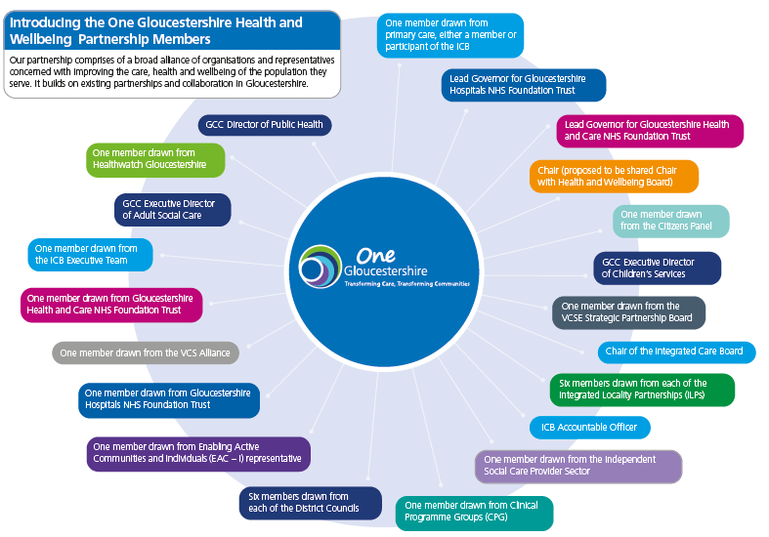

The GHWP and the Gloucestershire Health and Wellbeing Board (GHWB) have a very close interface. We have described it as ‘operating with a semi-permeable membrane’ whereby there are members of the GHWP who will also either be members of the GHWB or be invited to attend specific GHWB meetings.

There are already a large number of system wide priorities including priorities from the GHWB, strategic partnerships such as Enabling Active Communities and Individuals (EAC-I) and Healthy Communities Together, and the work delegated to and led through Clinical Programme Groups (CPGs) and Integrated Locality Partnerships (ILPs). These priorities cannot be delivered by the public sector alone. Civic society, and our communities, are essential to the success of achieving positive outcomes in each of these priorities. The GHWP will work to add value to the delivery of agreed programmes, in line with shared priorities. Striving for health equity will be the golden thread through the work it oversees or supports.

# **3. Introducing our vision**

### *Box 4: Feedback themes from engagement (Part 1)*

* **Preventing** ill-health and promoting the benefits of staying well​
* Addressing the **‘wider things’ (determinants)** that can impact on people’s health and wellbeing ​
* Developing the role of **primary care and community** services in improving access, supporting independence and joining up care in neighbourhoods ​
* Improving **mental health** support - including prevention, access and reducing social isolation and loneliness​
* Improving **access** to services and the effectiveness of care - including personalised care (care tailored to the individual’s needs)
* Developing **stronger partnerships** with the voluntary and community sector. ​

In accepting the challenge to develop this interim Integrated Care Strategy for Gloucestershire, we sought to build on the evidence, engagement, and good work already underway in our system. We identified multiple strategies and documents that describe the great work already taking place and sought to understand how we can bring these together under the Gloucestershire Health and Wellbeing Partnership (GHWP).

A comprehensive public engagement exercise (Part 1) was undertaken during January to March 2022, asking local people how they would like to be involved, and the areas or issues they wanted us to consider, as we developed the strategy. We asked for the top three things people thought we could do to improve health and wellbeing in our county (summarised in the [Output of Engagement Report 1](https://getinvolved.glos.nhs.uk/13491/widgets/55688/documents/32249)). Further engagement (Part 2) to develop this interim strategy was targeted at stakeholders rather than the wider public, whose views have already shaped this document. Through this further engagement we iteratively developed the vision, principles and structure of the strategy, testing and reviewing this with our partners (a summary of the engagement can be found [here](https://getinvolved.glos.nhs.uk/ics-gloucestershire)).

# **4. Strategy on a page**

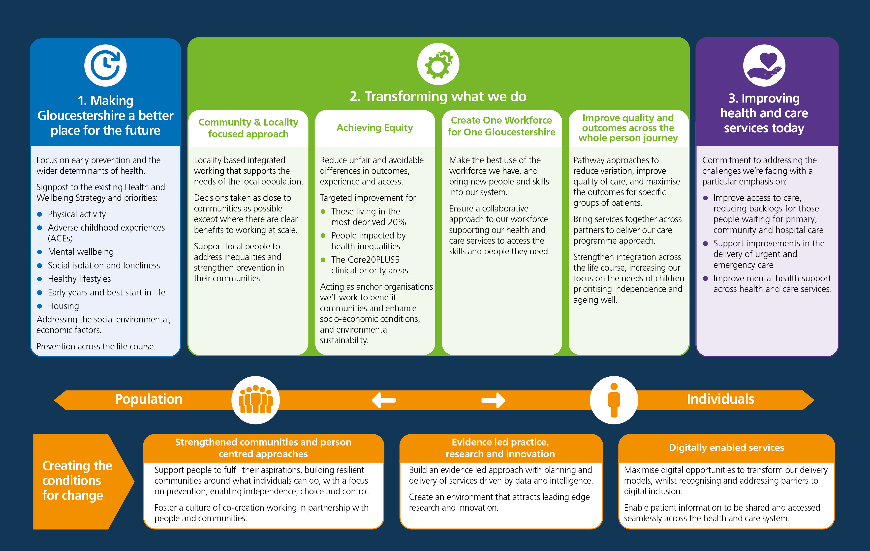Translating what we have heard from our engagement, we have identified 3 overarching ‘pillars’ and 3 ‘conditions for change’.

# **5. Understanding wellbeing, prevention and health equity**

## **5.1 Wellbeing**

Throughout this strategy we talk about health and ‘wellbeing’. Simply put, wellbeing is about ‘how we are doing’ as individuals and communities. It encompasses the environmental factors that affect us, and the experiences we have throughout our lives. Whilst this is a broad concept, the Care Act 2014 described it as relating specifically to the following areas:

Personal dignity (including treatment of the individual with respect)

Physical and mental health and emotional wellbeing

Protection from abuse and neglect

Control by the individual over day-to-day life (including over care and support provided and the way it is provided)

Participation in work, education, training or recreation

Social and economic wellbeing

Domestic, family and personal

Suitability of living accommodation

* The individual’s contribution to society

## **5.2 Prevention**

*Figure 1*

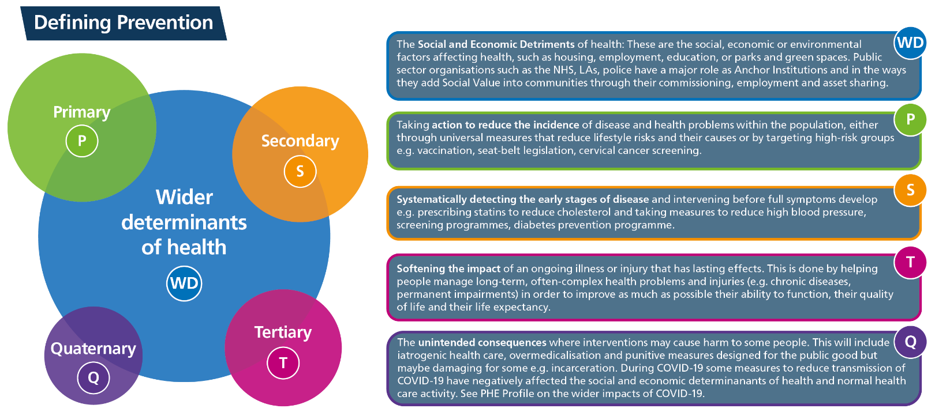We must prioritise prevention, early intervention, and tackling the causes of health inequalities. Prevention must be embedded across all our work. Prevention is about helping people stay healthy, happy and independent for as long as possible. It means stopping problems from arising in the first place; focusing on keeping people healthy and thriving, not just treating them when they become ill. It’s not only preventing illness and dependency, but actively promoting a positive state of health and wellbeing. We need to be mindful that prevention activity should not widen inequalities. So, we need to resource and deliver universal prevention but at a scale and intensity proportionate to the degree of need.

Prevention can be understood in terms of contributing to ‘today’s issues’ whilst also seeking to avoid ‘tomorrow’s.’ The benefits of a preventative approach can be quickly seen for our citizens and the services that we provide. At a population level, health improvement opportunities which look to prevent the need for treatment services are more cost effective than treating people. We are serious about refocusing upstream, and therefore we will place an emphasis on ‘primary prevention’ (see Figure 1).

## **5.3 Health equity and health inequalities**

Health equity is realised when every individual has a fair opportunity to achieve their full health potential. Differences in health status, access to care, treatment, and outcomes between individuals and across populations that are systemic, avoidable, predictable, and unjust are often referred to as health inequalities (or disparities). These differences occur between people or groups due to social, geographical, biological, or other factors. These differences result in people who are worst off missing out on life chances, experiencing poorer health and having shorter lives.

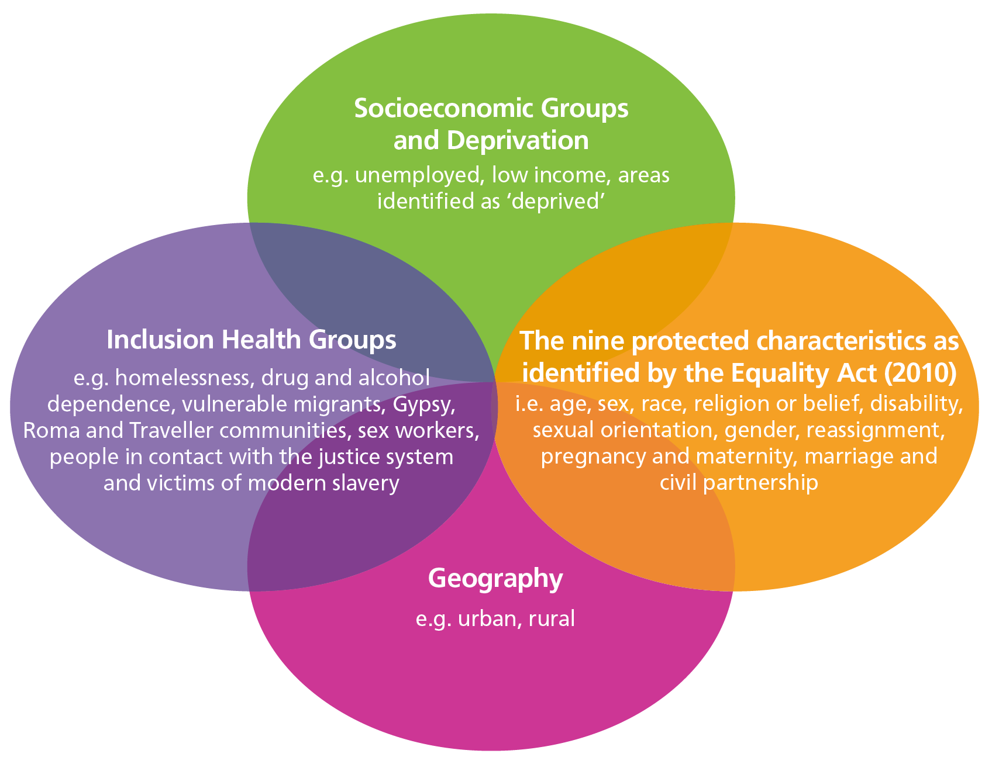

*Figure 2: The overlapping dimensions of health inequalities*

Health inequalities can relate to:

* Health status e.g. healthy life expectancy
* Access to high quality care e.g. access to clinical appointments
* Quality and experience of care e.g. patient satisfaction
* Health and care outcomes e.g. long term condition management
* Behavioural risks to health e.g. alcohol consumption
* Wider determinants of health e.g. quality of housing, long term unemployment

A wide range of groups in our population are at greater risk of experiencing health inequalities. These groups overlap; as individuals we are not defined by a single characteristic (see figure 2). Across all of the pillars (see section 4), we are committed to prioritising prevention and achieving health equity. This runs as a golden thread through the strategy. Furthermore, we recognise that this strategy needs to take into account assets and needs of the whole population. As such, a life-course approach also acts as a golden thread through the strategy.

Our commitments to prevention and health equity are:

* Advocating for, and leading on, prevention across our system: – we recognise that every individual, community and organisation has a role in prevention and want to support the development of those roles even further.
* Providing a strategic oversight of prevention and health inequalities in our system to enable a better understanding of impact and areas to prioritise.
* Addressing the biggest risk factors causing preventable premature death or disease.
* Supporting communities to be resilient, connected, healthy, happy, and safe so that everybody can start, live and age well.

|  |  |
| --- | --- |
| **In 12 months, we will see:**   * Clear system governance for prevention and health inequalities * Plans to ensure a basic level of understanding of prevention across the system * Agreed system matrix for measuring the impact of prioritising prevention. | **In 5 years, we will see:**   * Prevention embedded in health, care and wellbeing policies and programmes across our system. * All staff and partners working in our system have a basic understanding of prevention and their role in prevention. * Prevention activity embedded across the Core 20 plus 5 work (see section 8.2.2). |

# **6. Gloucestershire: Understanding our population**

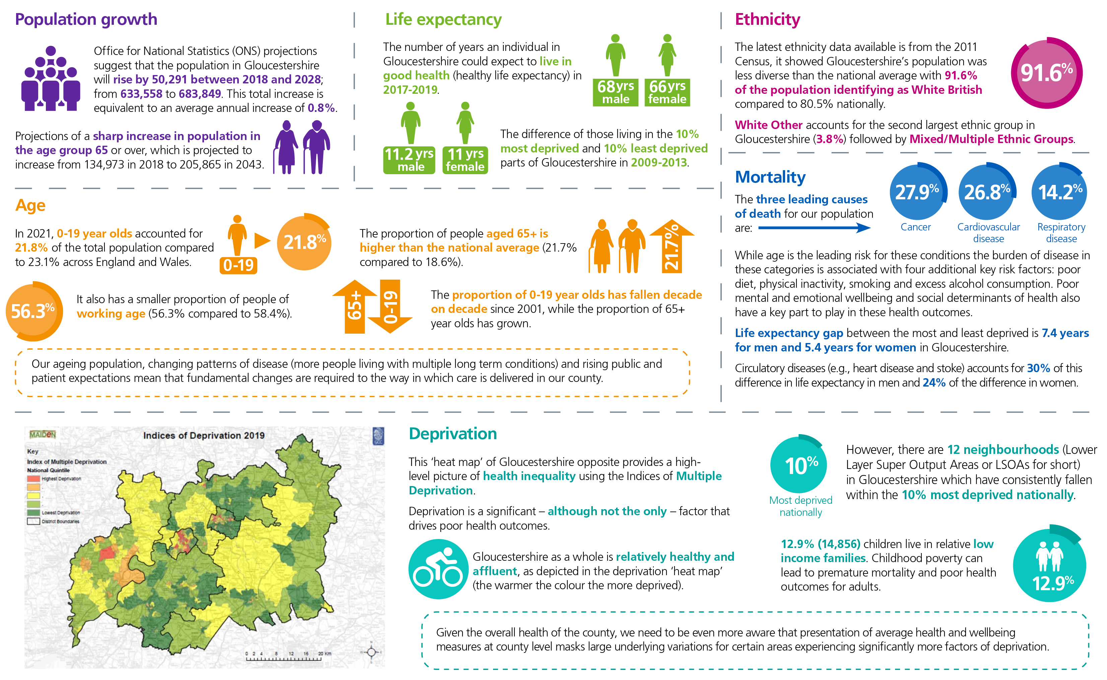The health of people in Gloucestershire is generally better than the England average. Gloucestershire is among the 20% least deprived counties/unitary authorities in England. Average life expectancy is 80 years for males and 84 for females, which is better than national averages. However, this is not evenly distributed across the county. Furthermore, the demographics and the needs of our population are changing (See OHID, [*Fingertips*](https://fingertips.phe.org.uk/profile/public-health-outcomes-framework/data#page/1)). It is important to note that 2021 census data is currently being released and therefore this data section will be updated in future iterations of this strategy.

# **Pillar 1: Making Gloucestershire a better place for the future**

**6.1 The case for change**

### *Figure 3*

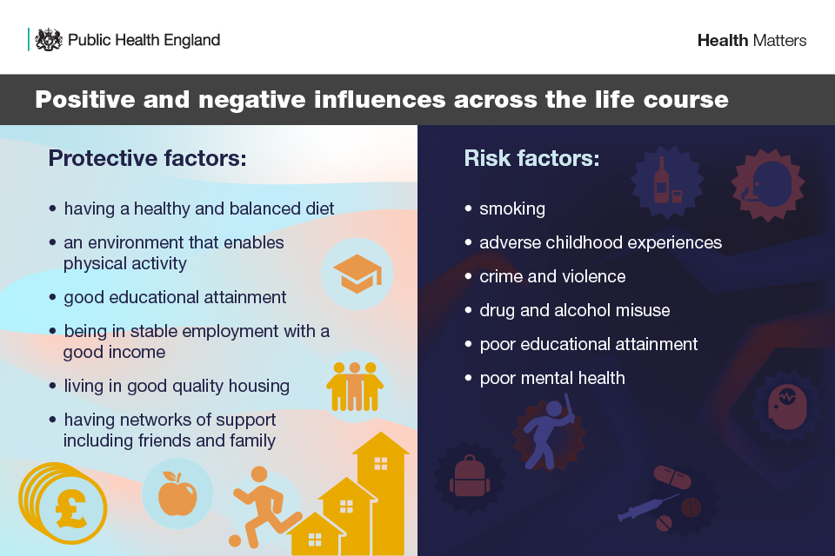

To make Gloucestershire a better place for the future, there is an urgent need for effective approaches to prevention, particularly ‘upstream’ interventions which impact on the wider determinants of health and wellbeing (economic, social and environmental factors).

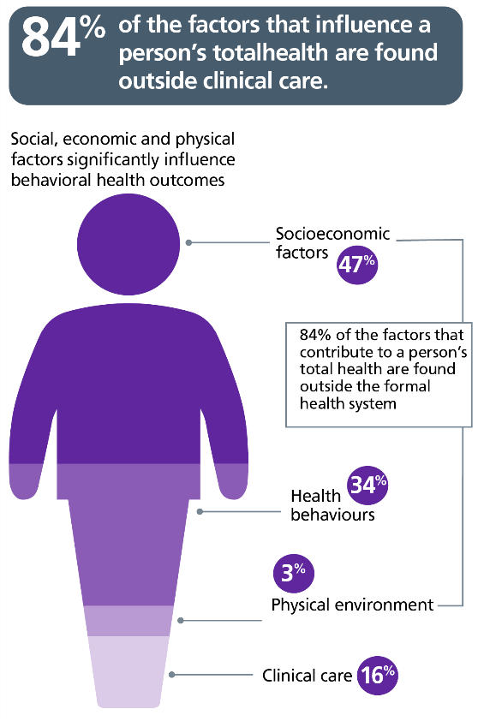Some causes of death can be avoided or delayed through effective public health and primary prevention interventions. According to the Global Burden of Disease (GBD) study in 2019, the top five risk factors contributing to avoidable deaths in England are smoking, poor diet, high blood pressure, obesity, and alcohol and drug use. Furthermore, it is estimated that 40% of the demand on health services in England could be avoided if we acted on these risk factors. Preventable ill-health has been estimated to account for 50% of all GP appointments, 64% of outpatient appointments and 70% of all inpatient bed days (BMA, 2018).

### *Figure 4*

These risk factors for preventable ill health and deaths are underpinned by wider social drivers. The wider (or social) determinants of health refer to the social, cultural, political, economic, commercial and environmental factors that shape the conditions in which people are born, grow, live, work and age. As illustrated in figure 4, it is estimated that approximately 84% of what determines our health is contributed by non-healthcare factors such as social circumstances (47%), and health behaviour patterns (34%) such as diet, smoking, physical activity and alcohol intake. Prioritising prevention will improve the population’s health, protect the NHS, and allow more people to stay healthy and independent for longer.

The case for investing in prevention is compelling. Despite this, only around 4% of the UK health budget is spent on prevention (The Health Foundation, 2016). Prioritising prevention will improve the population’s health, protect the NHS, and allow more people to live longer healthier lives.

In prioritising prevention, we will focus on identified assets and needs in Gloucestershire, draw from evidence of what works, and recognise the valuable strengths, assets and enablers that are already in place and which need to be maintained.

|  |  |  |  |  |  |
| --- | --- | --- | --- | --- | --- |
| **DATA AND INTELLIGENCE:** | | | | | |
| In 2020/21 there were **64.9%** adults that live with obesity or being overweight in Gloucestershire compared with **63.5%** in England | **10.3%** of Reception aged children who are living with obesity in Gloucestershire, compared with **9.9%** in England | | In 2020, **11.6%** of adults in Gloucestershire smoked tobacco which is in line with the England rate of **12.1%** | | In 2019/20 only **12.25%** of adult self-reported that they walk for travel at least three days per week. This is significantly worse than England value of **15.1%** |
| **51%** of adult social care users over 18 years feel as though they have as much social contact as they would like compared to the England average **45.9%** | | In 2022, **1 in 4** (26%) of all Gloucestershire pupils reported low mental wellbeing. An increase of 9.5 percentage points since 2016 (16.5%). | | **Over half** of Y10 female pupils report low mental wellbeing in Gloucestershire | |

## **6.2 How are we already creating change?**

### *6.2.1 Strategic oversight - Gloucestershire Health and Wellbeing Board*

The Gloucestershire Health and Wellbeing Board (GHWB) vision is that ‘*Gloucestershire is a place where everyone can live well, be healthy and thrive’*. The [Gloucestershire Health and Wellbeing Strategy for 2019 – 2030](https://www.gloucestershire.gov.uk/media/2106328/gcc_2596-joint-health-and-wellbeing-strategy_dev12.pdf#:~:text=Gloucestershire%E2%80%99s%20firstJoint%20Health%20and%20Wellbeing%20Strategy%2C%20Fit%20for,development%20sessions%20and%20formed%20new%20ways%20of%20working.) sets out key priorities, which focus particularly on addressing wider determinants of health, and some elements of primary prevention. GHWB is focusing on seven priorities - selected based on data and intelligence as well as stakeholder input. Progress against the priorities is delivered through county-wide partnerships, strategies and plans

### *Box 5: GHWB priorities*

* Physical activity
* Adverse childhood experiences
* Mental wellbeing
* Social isolation and loneliness
* Healthy lifestyles
* Early years and best start in life
* Housing and health.

### *6.2.2 Addressing wider determinants of health*

The GHWB strategy has a strong focus on the social drivers for health and wellbeing. However, there are other wider determinants of health which are addressed in other parts of our system:

### *Box 6: Explanation of the social, economic and environmental determinants*

|  |  |  |
| --- | --- | --- |
| **Social factors**  A wide range of social factors influence our health and wellbeing, from how we connect with people in our community to how safe we feel. For example, a fear of crime may be a barrier to individuals engaging in health improving activities, including outdoor activities (such as walking and cycling) or connecting with neighbours. This is addressed through the county wide partnership Safer Gloucestershire with the  *Gloucestershire Community Safety Strategy**.* | **Economic factors**  Being in a good, stable job is an important determinant of health and wellbeing. The long-term unemployed have a lower life expectancy and worse health than those in work. The effect of unemployment does not just affect individuals. Children growing up in workless households are almost twice as likely to fail at all stages of education compared with children growing up in working families. We also know that a healthy and happy workforce is a more productive one. So, what’s good for health can also be good for the economy. [*Gloucestershire’s Local Industrial Strategy*](chrome-extension://efaidnbmnnnibpcajpcglclefindmkaj/https:/www.gfirstlep.com/downloads/2020/gloucestershire_draft_local-industrial-strategy_2019-updated.pdf) (2019) focuses on how we drive productivity and prosperity in our county and support an inclusive economy. | **Environmental factors**  Modifiable environmental factors, such as outdoor air pollution, damp housing, exposure to hazardous materials at work and built environments that discourage physical activity. These influence health and wellbeing. For example, air pollution is one of the major environmental determinants of health. Long-term exposure to air pollution causes chronic conditions such as cardiovascular and respiratory diseases, as well as lung cancer, leading to reduced life expectancy. The *Gloucestershire Air Quality and Health strategy* describes the strategic approach to improving air quality and mitigating its impact on health. |

### *6.2.3 Looking across the life course*

A life course approach considers the critical stages, transitions, and settings where large differences can be made in improving or restoring health and wellbeing. This approach means identifying opportunities for minimising risk factors and enhancing protective factors through evidence-based interventions at important life stages. Looking through a life course lens stimulates action on the wider determinants of health, both to address negative risk factors and build empowered and resilient individuals and communities.

The Child Friendly Coalition brings together a diverse range of agencies from across all sectors, with a shared commitment to improving outcomes for children and young people in the county. [*Working together to create a child friendly Gloucestershire*](https://getinvolved.glos.nhs.uk/ics-gloucestershire) (2022) is a strategy which sets out the overarching aim for Gloucestershire to become a ‘child friendly county’, within which all partners view children and young people as an asset to be valued and nurtured for the future. Immediate priorities for action include pre-birth to 5 years, mental health, and emotional wellbeing, as well as transition from education to business or further education. These reflect the views of children and young people, the emerging evidence of the extent and nature of the impact of COVID-19, and key aspects of local performance in the health and care of children and young people.

### *Box 7: This Mum Can campaign*

In 2019 Gloucestershire County Council commissioned a social marketing pilot using sustainability and transformation plan prevention funding to develop a campaign to promote breastfeeding amongst young mums in areas of Gloucester City where prevalence rates are lowest. The outcome was the This Mum Can campaign (@thismumcanglos on Instagram) which includes humorous, informative, and affirmative messages as well as the innovative ‘champion’ model where real Gloucester based young mums share their story for a small incentive. The team have also delivered a series of webinars delivered by breastfeeding and child health experts and face to face breastfeeding support groups. The campaign achieved good reach and feedback from followers showed approximately 2 in 3 (67%) women agreed that This Mum Can encouraged them to start/continue breastfeeding, 82% said the campaign made them feel empowered and 2 in 3 (68%) women stated they felt more confident to breastfeed in public. In response we’re now looking to embed the campaign through our Children and Family Centres and expand the remit across broader health promotion messages.

*6.2.4 Focusing on primary prevention*

### *Box 8: Women’s South Asian healthy weight programme*

Gloucestershire healthy lifestyles service has delivered a healthy weight programme for South Asian women in Gloucester. The programme was co-designed with women to ensure it met the specific needs of women from that community and the needs of their families. Members of the community were also involved in the delivery of the programme with community champions being paid to help deliver some sessions. The 12-week programme included physical activity taster sessions (offered via GL1), healthy eating sessions, and health talks on the menopause, diabetes and mental wellbeing.

Participant feedback about the programme was very positive and most participants increased their physical activity levels and lost weight. The programme will continue to be developed over the coming year.

There is already a great deal of innovative work across the system aiming to keep people healthy, for example the women’s South Asian healthy weight programme outlined in box 8. However, there would be benefit to having a greater system overview of this work to understand what is working well, make links between programmes and acknowledge where we need to give more focus.

### *6.2.5 Preventing the spread of infectious diseases and environmental hazards*

We consider communicable (infectious) disease health protection risks collaboratively through the Health Protection Assurance Board involving UKHSA, local authorities and the NHS who have health protection responsibilities to deliver improved outcomes for the population and communities served. This complements the Local Health Resilience Partnership which takes action to ensure that health and care services are prepared to respond to health protection emergencies including environmental hazards.

## **6.3 Our ambitions**

To make Gloucestershire a better place for the future we need to:

1. Improve and protect health and wellbeing
2. Reduce premature mortality
3. Increase healthy life expectancy
4. Close the gap in healthy life expectancy between different areas and population groups within the county.

Through system wide ownership and commitment to making Gloucestershire a better place for the future, we must embed prevention in everything we do. Delivery of this pillar is through the Gloucestershire Health and Wellbeing Board.

## **7.1 The case for change**

### *Figure 5*

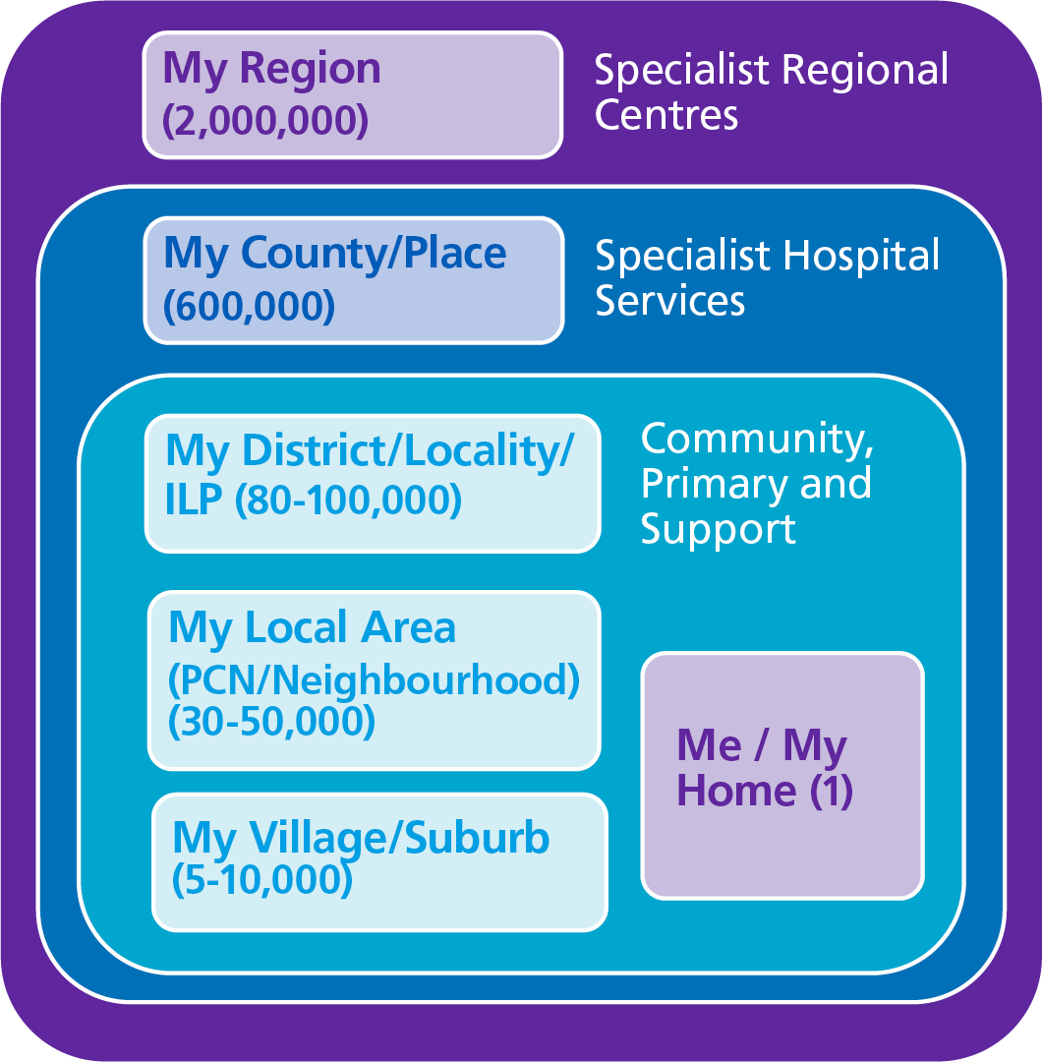

# **Pillar 2: Transforming what we do Community and locality focused approach**

Great ideas exist at a local level, people are proud of their communities and there is great value in making decisions as close to communities as possible; “nothing about us, without us”. There are many different ‘layers’ to working together and lots of good examples of working at locality, neighbourhood and ‘hyper-local’ (very small community) levels across Gloucestershire, through capitalising on community strengths, local knowledge and drive to make things better.

* **Integrated Locality Partnerships (ILPs)**: are non-statutory partnerships of Local Government, NHS, Voluntary Community and Social Enterprise (VCSE) sector, housing and increasingly communities, people and wider partners such as police, education etc. Their aim is to:
* proactively reduce the impact of root causes of health inequalities
* improve health and wellbeing
* work collectively to redesign care for and with people in the locality to enable people to live well at home.

There are 6 ILPs in Gloucestershire, aligned to the 6 districts – although there are some differences between ILPs and districts due to the locations of some GP practices.

* **Primary Care Networks (PCNs):** groups of GP practices working together in partnership with community, mental health, social care, pharmacy, hospital and voluntary services, in a joined-up way to provide care closer to home. There are 15 PCNs in Gloucestershire.
* **My village/suburb:** Communities working together at a hyper-local level.

## **7.2 How are we already creating change?**

An overarching plan for developing Integrated Locality Partnerships across Gloucestershire (2022 -2025), is being drafted. Working countywide does not work for everything and some localism is required to reflect differing population needs, the impact of existing community strengths (e.g. assets and services) and geographical differences such as rurality. Engaging with the 15 PCNs in Gloucestershire would not be easy or efficient for all partners. ILPs, by joining together partners around one or more PCN or neighbourhood population, give an achievable scale for meaningful and impactful partnership working. This mechanism also gives us an opportunity to recognise and contribute to the wider determinants of health, rather than focusing solely on clinical interventions. Alongside locality and neighbourhood working, we need to be mindful that there are positive examples of community-led activities at a hyper-local level; driven by communities themselves, and these need encouragement to flourish. These are communities with purpose, understanding and drive to improve the lives of their residents, friends or families, and who have a voice, opinions, and solutions. We need to work as a system to encourage and support these initiatives; and not look to control them. A great example of purposeful community-led activity and action is ‘The Power of Three’ (see box 9).

## **7.3 Our ambitions**

### *Box 9: The Power of Three – Matson, Robinswood and White City community partnership*

Over the last five years the Power of Three project, run by the Matson, Robinswood and White City Community Partnership, has worked together to tackle the negative images of the ward. The community has gone from strength to strength and the results have been local understanding of issues and a ‘what can we do for ourselves’ approach alongside closer links with statutory bodies (but in partnership) and working to support individuals, families and statutory services/agencies to engage more effectively capitalising on existing relationships and a true understanding of issues, challenges, strengths and opportunities.

The partnership has gained in confidence and engages with external agencies to represent their community and to be partners in co-creation. They have developed a ‘Power of Three’ economic development plan, setting out six purposes to lay the economic, environmental, social and development potential as well as opportunities to layer in context specific to the ward and recognise the benefit of collaborative working.

### *Box 10: Gloucester City ILP respiratory and housing project*

There is clear evidence of the association between respiratory conditions and an individual’s housing conditions. Working with other ILP partners, Gloucester City Homes, the local independent housing association, wanted to address housing related factors connected with respiratory issues for their tenants. We know that bringing together the right partners and people that are close to the communities we serve brings about positive, strengths-focussed change.

The project focuses on the connection between the treatment of respiratory conditions and the home environment as a wider determinant of health. It initially aims to improve and quantify the care and health outcomes of 20 Gloucester City Homes tenants presenting with respiratory concerns in NHS settings. The identification of the cohort in this way triggers an assessment with required housing improvements made and thermal efficiency ratings carried out. The purpose is to supply evidence to support multi agency working for this group of patients and social housing tenants. An additional peripheral or indirect benefit of the project is further developing partnership working to support sustainable transformation across the ILP for the benefit of the population we serve.

Acknowledging the importance of relationship building as foundational to meaningful work at any level, we need to move towards reporting on and measuring the relationships, behaviours and actions that underpin success rather than just measuring interventions. An inclusive approach to broadening memberships of ILP meetings and related priority projects needs to continue, as does the more meaningful engagement with people and communities. There will be least one overarching system principle for all ILPs to ‘*deliver in a way that makes sense locally’*. This will help to bring forward delivery and sharing across localities.  Scalability of successful schemes does not mean exact replication. It involves acknowledging and managing the human factors of sustainable change, packaging the ‘principles for scalability’ rather than a wholesale ‘lift and shift’ or expecting the same outcomes in different areas.

|  |  |
| --- | --- |
| **In 12 months, we will see:**   * Greater involvement of people, communities and VCSEs in priority projects across localities, learning from the successes and challenges of strengths-based projects, with a focus on improving independence and health equity. This will result in meaningful impact for, and with, people in our communities. * Some system direction but local delivery in a way that makes sense to the local context, with clarity of where working at scale across the county makes sense, and where local adaptation, closest to communities will have greatest impact. * Strong governance with accountability for delivering transformational change and an acceptance that much of the impact will be felt in the medium to longer term, and that interventions may contribute to positive change rather than be fully attributable. * Consideration of resource allocation, human and financial, for longer term strategic direction of ILPs. | **In 5 years, we will see:**   * Strong, mature partnerships in each locality, with wider membership committed to partnership thinking by default for the shared purpose of collectively and proactively tackling the root cause of health inequalities and improving health and wellbeing in each locality and within the constituent neighbourhoods. * Measuring the relationships, behaviours and actions that underpin success/failure rather than just the interventions developed and supported by recurrent funding, however small, for sustainable impact. * Communities empowered to build on their strengths, assets and relationships, to positively impact population health and wellbeing, with more people living well in their communities. * Clearer alignment between priorities and resource allocation. |

**8.1 Case for change**

# **Pillar 2: Transforming what we do. Achieving Equity**

# The pandemic has highlighted longstanding, systemic and avoidable inequalities or disparities in health status, access and experience of care, health outcomes and the wider social factors which influence health. There is a need to achieve equity to ensure everyone has a fair opportunity to achieve their health potential. There are many overlapping factors which can lead to health inequalities and people are often affected by more than one.

|  |  |  |  |  |
| --- | --- | --- | --- | --- |
| **DATA AND INTELLIGENCE:** | | | | |
| There are **31 neighbourhoods** (Lower Layer Super Output Areas[2] or LSOAs for short) in Gloucestershire which fall within the **20% most deprived nationally.** | **10.9% of children** under 16 years old are living in absolute **low-income families** in Gloucestershire. | You are **likely to live 11 years longer** in good health if you live in least deprived area of Gloucestershire compared to if you lived in the most deprived area of the county. | The **excess mortality** rate for those with severe mental illness (SMI) was **significantly higher** than the national average in Gloucestershire between 2018-2020.​ | In Gloucestershire the **gap in employment** between the those with a **learning disability** and the general population is significantly higher than the England average. |

## **8.2 How are we already creating change?**

As health inequalities are far reaching, no single intervention or strategy will address the wide and diverse issues faced, collective effort is needed. It is recognised that there is already much work happening across the county to achieve equity and in doing so address and reduce health inequalities; however, the challenge is achieving this across the system at scale and sustainably.

### *8.2.1 System level change: Using the population intervention triangle[3] as a framework for action*

The Population Intervention Triangle (PIT) is a national framework which was developed through practical experience working to achieve measurable population level change in health and wellbeing outcomes - including addressing health inequalities between and within local geographies. We have been using this model to understand where we can have the greatest impact and how to focus system leadership and planning. The model addresses the need for action on civic, service and community segments (see below). Joint working across the interfaces between these three segments is also needed to enable the whole to become more than the sum of its parts. This model offers a framework to enable the system to work across all segments, and to also step outside of traditional roles and boundaries. This combination of approaches is essential for developing and building complex, adaptive approaches to effect change at population level, achieve equity and reduce inequalities.

1. Strengthen community action

### *Figure 6: Components of the population intervention triangle*

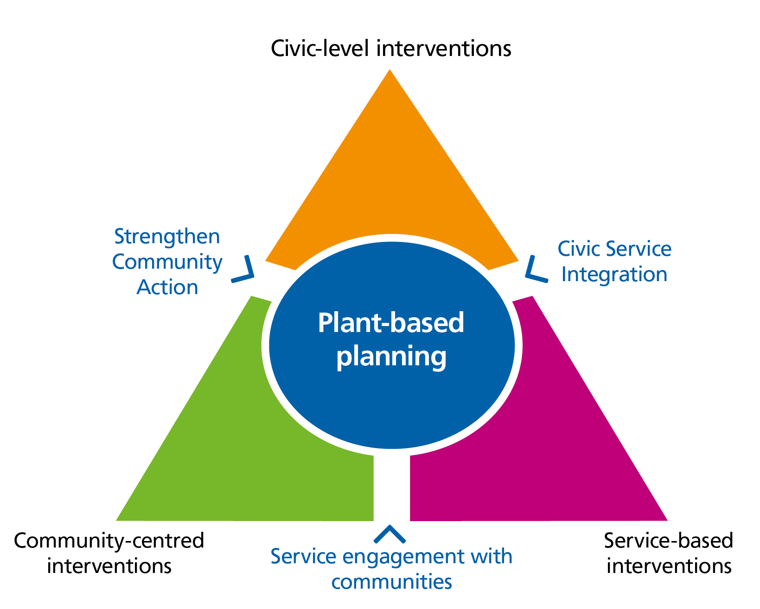

Within this ‘seam’, the role of civic authorities is to support local communities (of neighbourhood, culture, interest) to become empowered, resilient and independent, enabling them to support individuals and families to take more control of their health and wellbeing. An example of our work within this seam is ‘Levelling Up’ in Gloucestershire. Levelling Up has specific missions around decreasing gaps in life expectancy and wellbeing. To facilitate this, a Levelling Up Together grant scheme has been developed which will be focussed on the twelve most deprived LSOAs (equating to ten Wards) in the county.

1. Service engagement with communities

Although systems have been working to integrate their structures and processes, with focus on care closer to home, there are persistent barriers between systems and more disadvantaged people in their communities. People working in our system have said that ‘action on’ health inequalities is an important part of their role, but many have asked for better information, support, tools, models and learning mechanisms to assist them in this. Examples of action to date include the development of a health inequalities digital hub providing information, practical support and signposting for those wanting to consider their work area through a health inequalities lens.

1. Civic service Integration

Civic authorities, such as local councils and the NHS, work closely with a range of service providers. Examples of action to date include working with public sector organisations in Gloucestershire to prioritise health inequalities in their strategies and organisational ambitions; challenging them to think differently about their role in ‘action on’ health inequalities and reviewing and developing Gloucestershire County Council’s Equality Impact Assessment (EIA) process from a health inequalities perspective.

### *8.2.2 Programme level change: Core20PLUS5 key clinical areas*

The Core20PLUS5 framework has been developed nationally to support Integrated Care Boards to drive targeted action in health inequalities improvement. This invites a focus towards:

* Core20: anyone living in Gloucestershire who falls within the 20% most deprived communities nationally
* PLUS: this can be any Equalities Act or inclusion group that needs more focussed action.
* 5: five key clinical programme areas to deliver for the Core20 population. Clinical Programme Groups (CPGs) are exploring the beliefs and perceptions that influence people’s interaction with services and, working with integrated locality partnerships, are seeking to target improvements to access, experience and outcomes through their transformation programmes.

*8.2.3 Organisational level change: Anchor organisations*

The role of anchor organisations in our system presents an ideal opportunity to promote equity and consider how to reduce health inequalities. The term ‘anchors’ commonly refers to public sector organisations such as local authorities, hospitals and universities which are unlikely to relocate and have a significant stake in their local area. They have sizeable assets that can be used to support their local community’s health and wellbeing and address health inequalities (see Gloucestershire’s [*Director of Public Health annual report* 2021](https://www.gloucestershire.gov.uk/media/2111500/dph-report-2021-sources-of-strength.pdf)). These characteristics means they are well placed to positively influence the social, economic and environmental determinants of health and wellbeing within their local communities.

### *Figure 7 Opportunities for anchor organisations*

Anchor organisations already influence the wider determinants of health and wellbeing, but they can have a more positive impact by choosing to invest in and work with others locally and responsibly. For example, choosing to direct more procurement spend locally enables organisations to employ more people and pay higher wages. These employees are more likely to spend locally, thus stimulating the county’s economy further.

This approach capitalises on the substantial economic leverage that anchor organisations have as employers, purchasers of goods and services, land and asset owners and community leaders. Gloucestershire has been developing the anchor organisations approach locally through five areas of focus and developing a quality assurance matrix. One of these five areas of focus is environmental sustainability which demonstrates the role of anchor organisations in addressing their environmental impact and helping to response to the climate crisis.

### *Box 11: The Employment and Skills Hub*

The Employment and Skills Hub provides a “front door” to employment and skills support for all residents of Gloucestershire. The ‘Hub’ offers information, guidance, support, and advice to all, with 1:1 support for people who face additional barriers to entering the labour market or retaining their job. The Hub works across all sectors and with a network of partners to provide holistic support to residents and promotes inclusive employment practices to all employers encouraging them to build a workforce that is diverse and representative of the County’s population.

Within the Hub specialist services provide additional support to those who have an increased risk of long-term unemployment or economic inactivity, including young people who are/have been in care, who are not in education employment or training (NEET) or who have health conditions and disabilities, including those with mental health issues. With a focus on areas of highest deprivation the Hub reaches every part of Gloucestershire to ensure equality of opportunity for those who have, or could, experience health and social inequality.

## **8.3 Our ambitions**

The One Gloucestershire Health and Wellbeing Partnership (GHWP) and can play a key role in developing action across boundaries and will be pivotal in challenging thinking and traditional ways of working. It will:

* Ensure we have the drive to work differently; system leadership needs to be understanding of and engaged with the health inequalities agenda and be aware of its relevance to the wellbeing principle, inclusion, and other high priority issues.
* Develop robust partnerships supported by good governance. This will be essential for harnessing dimensions of system change, agreeing outcomes and integrating the health inequalities agenda with promoting independence and other priority activity – as a golden thread.

### *Box 12: Key ways we will achieve our health equity ambitions*

* Engagement: Developing engagement infrastructures to facilitate considered, two-way conversations with communities and cohorts (population groups).
* Data and Intelligence: Using data and intelligence to build a considered picture of health inequalities in Gloucestershire utilising a diverse set of methods and sources.
* Communication and Information: Developing a variety of mechanisms to increase in knowledge and awareness of health inequalities across the system.
* Embedding Policies and Processes: Creating the conditions to enable systematic consideration of health inequalities in business-as-usual activities.
* Workforce Capacity, Skills and Capabilities: Developing the skills, understanding and capabilities of organisations and their workforce in relation to health inequalities.
* Recognise that delivering services to achieve population level change and reduce health inequalities requires an understanding of how communities and individuals are supported to use services, alongside addressing variation in quality and outcomes of the services themselves.
* Develop the workforce capacity, motivation and skills to understand and address health equity and health inequalities.
* Use this opportunity to align our approach to health equity to the [Marmot principles](https://www.health.org.uk/publications/reports/the-marmot-review-10-years-on) on the social determinants of health.

We will link foundational cross-cutting activities to existing structures (for example our Integrated Locality Partnerships and Clinical Programme Groups) as well as ensuring any health and care strategies have health inequalities as a golden thread running through them.

|  |  |
| --- | --- |
| **In 12 months, we will see:**   * An anchor organisations approach: Public sector anchor organisations use the anchors progressive framework to self-assess where they are against each dimension and take actions to capitalise on their power and role as an inclusive anchor. * Routine use of equity research, data, and intelligence to inform service design, delivery, and improvements. * Focus on commissioning for social value and health equity principles, through robust Equality Impact Assessments (EIA) and implementation of a coproduced social value policy. | **In 5 years, we will see:**   * Workforce: All staff working in our system will understand health inequalities – what they are, why they matter and what action they could take within their roles. * Action across our partnership: Every service across our system understands how it can create equity and is structured to support this. * Evidence of action and progress on ensuring we do more for the most disadvantaged groups in our population, including evidence of reduced health inequalities across our system. |

.

# **Pillar 2: Transforming what we do. Create One Workforce for One Gloucestershire**

## **9.1 The case for change**

|  |  |  |  |  |
| --- | --- | --- | --- | --- |
| **DATA AND INTELLIGENCE:** | | | | |
| Over 28,000 people work in health and social care in Gloucestershire, but there are **vacancy rates of 7-12%** and even greater in some staff groups e.g., **registered nursing 14%.** | Over **11,000** people are employed by the Voluntary, Community and Social Enterprise Sector (VCSE) and there are **14,000 volunteers** | | Each year Gloucestershire experiences a **net loss of 400 people aged 18-30** who leave our county | |
| 9% of households in Gloucestershire are “Not in Work” with over **17,000 individuals currently unemployed.** | | The average age of our workforce is 43 years. **21% of NHS staff and 25.4% of social care staff are aged over 55.** | | Over **52%** of VCSE organisations **struggle to recruit trustees** |

The health and care workforce across our system is key to transforming what we do. However, workforce sustainability across our system partners is one of the biggest challenges we will face over the next 5-10 years to ensure we can continue to deliver effective services and care and improve the overall health and wellbeing for our population.

## **9.2 How we are already creating change?**

### *Box 13: The principles of our workforce approach*

* A sustained focus on retention of staff linked to a strong health and wellbeing offer
* Ensuring our workforce represents the population of Gloucestershire
* Growing our routes into local careers in caring working with Schools and Colleges
* Targeting education and training opportunities at roles that can work across health and care, community, and acute and physical and mental health
* Develop shared solutions to shared problems e.g., further system wide recruitment events, exploring potential for working at scale
* Support our voluntary and community sector through continuing to extend and share development opportunities, rotational roles and highlighting the profile of volunteering
* A shared focus on culture and compassionate leadership

Rather than tackle the workforce challenge as individual organisations, it is essential that we work together as system partners to find solutions that deliver a sustainable workforce for Gloucestershire. Working with our partners has identified a need to:

* prioritise the health and wellbeing of staff and develop a consistent approach to creating a compassionate culture across Gloucestershire.
* maximise opportunities for flexible working, for example through common policies, and harmonising Terms and Conditions, supporting staff to move across our system.
* widen access to health and care roles, creating career pathways for young people.
* change the perception of care roles.
* continue to work collaboratively on creative solutions that make the best use of all resources across our system
* strengthen the voluntary and community workforce across the country.

### *Box 15: Health are care recruitment event*

More than 300 people attended a ‘one stop shop’ recruitment event at Cheltenham Racecourse with a large number fast-tracked into job opportunities within health and social care in Gloucestershire. Gloucestershire NHS organisations, Gloucestershire County Council and the independent care sector joined forces to run the event which aimed to fill many vacancies across the health and care sector locally.

A total of 314 people were welcomed through the doors, 298 job seekers were interviewed and 270 of those were offered roles with 41% being new to care. The range of posts on offer included mental health, community services, adult social care, GP practice and hospital support roles.

### *Box 14: Gloucestershire GEM project*

The Gloucestershire GEM Project is a unique public, voluntary and private sector partnership. GEM has supported those who are furthest from the labour market to move closer or into education, employment, and developing skills. Reaching into communities, GEM has supported over 2,000 participants, reduced isolation and developed an extensive and diverse partnership that builds capacity and cohesion.

GEM has provided us with an evidence base upon which we can build future employment and skills programmes for the County’s unemployed and economically inactive residents, addressing socio-economic factors experienced by some of the county’s vulnerable or excluded individuals.

## **9.3 Our ambitions**

Across our partnership colleagues engaged in supporting the workforce have agreed our approach should be to pool resources, reduce duplication and identify priority areas for collaboration with all partners having an equal voice. We will also identify best practice and learn from other areas who have adopted innovative approaches to addressing workforce challenges.

* We will further develop a shared People Plan for Gloucestershire that sets out our shared vision and priorities for the next 5 years.
* We will develop a supportive culture across our system that prioritises wellbeing, open communication and creates opportunities for leadership to flourish at all levels.
* We will continue to identify opportunities for joint working, including shared recruitment events and campaigns, leadership development and develop consistent approaches to equality, diversity and inclusion.
* We will maximise education and training opportunities for our workforce, taking the opportunity to share skills and knowledge across partners to develop a system understanding and equip the health, care voluntary and community workforce with the right skills for both current and future roles.
* We will strengthen our approach to apprenticeships and widening participation in health and care roles
* We will maximise wider partnerships to make the best use of all resources e.g. mobilising the Arts Health & Wellbeing Community Resource and Centre of Excellence (part of the new City Centre Campus and a joint initiative between One Gloucestershire and the University of Gloucestershire).
* We will use our substantial economic leverage as anchor organisations to develop employment opportunities for those furthest from the labour market.

|  |  |
| --- | --- |
| **In 12 months, we will see:**   * A reduction in vacancies and turnover rates across all system partners. * Further expansion of apprenticeships roles, internships, volunteering and other alternative routes to employment. * A system wide Workforce Wellbeing Strategy and support offer for the workforce across Gloucestershire. * Cross-sector career development opportunities including the opportunity for more employed staff to sit on VCSE sector boards. | **In 5 years, we will see:**   * Vacancy rates across all partners in our system reduced by 50%. * More individuals with protected characteristics, including Black Asian and Minority Ethnic groups are in senior leadership positions across partners. * A system wide learning and development platform across Gloucestershire accessible by all partners organisations. * Greater employment mobility across public, voluntary and community sectors but with strong retention across the County. |

# **Pillar 2: Transforming what we do. Improve quality and outcomes across the whole person journey**

**10.1 The case for change**

Considering the whole person journey for specific health conditions, or specific groups in our population enables a system wide view to improving the quality of care, and outcomes from prevention through to diagnosis and treatment. Premature mortality is a good high-level indicator of the overall health of a population. The under 75-year-old rate of mortality from all causes in Gloucestershire is 300 people per 100,000*, significantly better than England. However, there are significant differences in the premature death rates in different parts of the county and different population groups, reflecting a range of underlying differences between these populations.

## *Fig. 8: Breakdown of the life expectancy gap between the most and least deprived quintiles of Gloucestershire by cause of death, 2020 to 2021 (Provisional)*

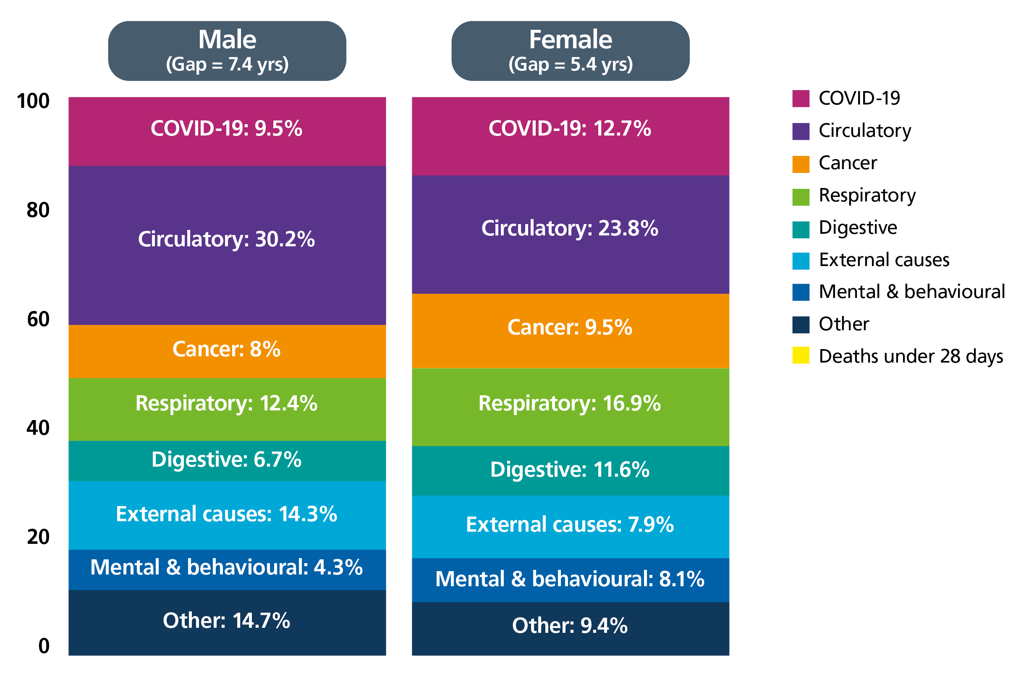

Figure 8 shows ’scarf charts’ which indicate, for each broad cause of death, the percentage contribution that it makes to the overall life expectancy gap between least and most deprived areas of Gloucestershire. For example, circulatory diseases are responsible for 30.2% of the 7.4 year gap in life expectancy between males living in our most and least deprived communities. Furthermore, COVID-19 is evident as a contributor during this period.

In Gloucestershire 14.6% of people aged 16+ are estimated to have a common mental health disorder and between 2018-20, 84.3 per 100,000 people in Gloucestershire suffered premature mortality due to severe mental illness. Whilst this is significantly better when compared to England as a whole[4] it masks differences across the county. Furthermore, individuals living in Gloucestershire who fall within the 20% most deprived communitiesnationally are more likely to be frail than the rest of the population. In May 2022, 13.4% of the 20% most deprived population in our county were considered frail versus 12.4% of the whole population using a frailty index to define mild, moderate and severe frailty[5].

To improve the quality of care and outcomes, and reduce inequalities between different groups, our system is taking concerted action in both prevention and treatment across the whole person journey for specific health conditions, or specific groups in our population.

*Note: Age-standardised rates of mortality in persons less than 75 years per 100,000 population. 3-year range average (2017-19).

**10.2 How are we already creating change?**

### *10.2.1 Transformation programmes*

Our transformation programme areas include defined clinical areas (such as Respiratory), defined patient groups (such as Children and Young People) and themes (such as Aging Well) in Gloucestershire.

A number of these programmes use the clinical programme approach methodology to work collaboratively to improve the quality of care, outcomes for citizens, and value for money. It also provides the opportunity to improve health equity across the whole patient journey. It involves using population health data and insights to inform the systematic redesign of the way care is delivered, by reorganising and integrating systems, to deliver the right care, in the right place, at the right time. It relies on partnership working across a range of sectors to co-produce pathways of care through primary and secondary prevention, diagnosis, treatment, and self-management, as well as transition, maintaining independence through adulthood and ageing well. It includes considering alternatives to traditional care, e.g., creative health and psychological support, to provide a holistic approach. This ensures a focus on evidence-based practice, local data and intelligence, and outcomes that are locally agreed and reflect a person-centred, multi-disciplinary, multiagency approach.

Our transformation programmes also seek to improve the quality of care and outcomes for a person’s journey across the life course; to enable people to maintain good functional ability through prevention and early identification and intervention. This perspective encourages us to consider critical stages, transitions, and settings where large differences can be made in improving health and wellbeing.

### *Box 16: Start well*

As a system we place high importance on health and care services supporting all children and young people in Gloucestershire to make a strong start. Gloucestershire’s Local Maternity and Neonatal System (LMNS) was established as a national requirement in response to the National Maternity Review ‘Better Births’ report (2016). The LMNS operates in a similar way to the CPGs by bringing together provider, commissioner, VCSE and service user stakeholders to improve quality and outcomes and reduce inequalities. Its vision is to improve maternity services to ensure that women and babies receive excellent care that is person-centred and safe, delivered by staff who provide woman-centred care, in cultures which promote innovation and continuous learning across organisational and professional boundaries. To ensure equity for mothers and babies in Gloucestershire, we must respond to each woman’s particular health and social situation and ensure that increased support is given to those with the poorest outcomes.

### *Box 17: Age well*

The ageing well, frailty and dementia programmes all use the transformation approach to improve the quality of life for older people and those living with these conditions. Key programmes of work include:

### *10.2.2 Linking transformation programmes with communities and localities*

We recognise that service access, delivery and support needs vary for different populations and areas within the county. Transformation programmes working together with localities and neighbourhoods will be key to understanding the causes of this unwarranted variation. Driving change from a place level using the best evidence and making appropriate changes to meet the needs at local level will be important for our success in improving outcomes for all.

### *Box 18: Examples of working between transformation programmes, communities and localities*

|  |  |  |
| --- | --- | --- |
| In **St Paul’s PCN a Population Health Management** (PHM) approach (see section 13.2.1) was used to identify patients in the risk category for COPD without a diagnosis. They were invited to a Lung Health Clinic.  The **Respiratory Clinical Programme Group** has supported this approach and has identified other ways to support patients, e.g., through the Lung Health Clinic such as education on the benefits of referral to pulmonary rehabilitation, provision of spirometers and training. Evaluation has identified that 59% of those who attended a clinic had an abnormal spirometry result, contributing to a high yield of new diagnoses of COPD. | The **Mental Health Clinical Programme Group** has actively engaged people with lived experience (including carers) in the planning and development of Mental Health services. An Expert by Experience Advisory Group has been established,  The Group are active participants in shaping and transforming local mental health services, with representatives attending the wider Clinical Programme Group meetings to support decision making. | Our strong partnerships with **Creative Health in Gloucestershire** provide options for people with long term pain, respiratory conditions, and dementia to access art and singing groups with some excellent results and feedback.  Further evaluation and exploration on these alternatives to traditional care will continue, including how to make this an accessible option for all our population. |

### *10.2.3 Involving experts by experience*

Involving experts by experience is fundamental to quality improvement. An example of this in Gloucestershire is the LeDeR programme. This is a service improvement programme which aims to improve care for people with a learning disability and people with autism; including working to reduce health inequalities and preventing early deaths.

Gloucestershire is one of the first counties to include experts by experience on their LeDeR quality assurance panel (where each review is considered by a wide range of stakeholders). The experts by experience are also involved in steering the programme and ‘action into learning’ groups, placing the voice of people with learning disabilities and people with autism at the heart of the programme. Having an expert by experience at every level brings constructive challenge and brings to life the barriers experienced by people with a learning disability or autism. Listening to the experts by experience has informed practical and useful improvements in care and communication.

### *10.2.4 Achieving health equity*

Looking across the whole person journey or pathway provides the opportunity to understand where health equity can be improved. The Intervention Decay Model (IDM) is a way to systematically use data to assess the effectiveness of a patient pathway for different groups of the population. Intervention decay occurs where at each ‘stage’ of an intervention or pathway cases are either ‘lost’ or do not receive optimal care. This means that there is a reduction in overall population level benefit from the intervention. The IDM tool helps to identify where these losses are happening and where inequalities exist along a pathway i.e., the points where different population groups are more likely to be ‘lost’ or receive sub-optimal care. The tool does not help to explain *why* these losses or disparities occur but highlights practical intervention points where NHS services and wider partners can work together at local level to understand the underlying reasons and agree actions to improve overall outcomes and reduce disparities. This model is being used by the Respiratory Clinical Programme Group with an ambition to broaden its use in the future.

**10.3 Our ambition**

We have identified the following key success factors for improving quality and outcomes across the whole person journey:

* Harnessing and utilising a partnership approach.
* Identifying those most at risk of long-term conditions, or deterioration, by utilising population health data and supporting tools, such as the intervention decay model.
* Delivering activities focussed on prevention and promoting independence.
* High-quality strengths based person-centred care, including additional offers for people outside of the “usual” care offer.
* A localised approach to service delivery – through co-production and further developing the relationships between transformation programmes and Integrated Locality Partnerships (ILPs).

There is an opportunity to build on the current approach to improve health equity by:

* Routinely and robustly considering health inequalities as part of service development/change through the meaningful application of the organisational Equality Impact Assessment process.
* Embedding meaningful engagement with communities throughout all service/pathway improvement work – from design to delivery.
* Making better use of data, including Population Health Management (PHM) approaches, and more effective use of qualitative data, to help ask different questions around service accessibility, experience, outcomes, and equity.
* Systematically applying the Intervention Decay Model to services and pathways to understand and act on inequalities in access, experience & outcomes.

Whilst there are examples across our programmes of where this is already working well, we will more consistently embed these success factors throughout our programmes, taking every opportunity to share learning with one another, allowing our approach to continue to develop and grow.

|  |  |
| --- | --- |
| **In 12 months, we will see:**   * Programmes robustly using population health data, as well as qualitative insights and information, to inform project development and planning. * All programmes identifying their contribution to the CORE 20 PLUS 5 agenda and reporting on progress and impact. * All programmes committed to the concept of preventing, reducing, or delaying need for care and support, to reduce demand on urgent care services and improve elective recovery. | **In 5 years, we will see:**   * All programmes achieving health equity (see section 5.3) in outcomes and access for services in Gloucestershire. * Our resources being used effectively and efficiently across the system to deliver high value care, which is demonstrated in outcomes. * Countywide and local services that are fit for purpose, responsive to people’s needs, build on the strengths and assets of individuals and communities, and meet our constitutional standards. |

**11.1 The case for change**

# **Pillar 3: Improving health and care services today**

Our first Integrated Care Strategy recognises that, as well as setting our strategic direction, we also need to respond immediately to the pressing challenges facing our system. These challenges include:

* Ongoing pressures within our urgent and emergency care system.
* Completing the post-pandemic recovery phase.
* Significant workforce pressures.
* Growing financial challenges across the system, and for the individuals we serve.

In order to respond to today’s challenges, we have explored a wide range of quantitative and qualitative data and intelligence to help further define these:

* The challenges within urgent and emergency care services continue to be significant; in particular patients are waiting too long to be seen at our emergency departments (including delays to handover patients from ambulances); patients are staying in hospital longer than they need to because we are too reliant upon bed-based discharge pathways; and we need to increase capacity within out of hospital/home-based support services.
* We have made good progress in reducing the longest waits for hospital-based services but need to continue to be concerned about the size of the overall waiting list built up during the pandemic (when resources were redeployed to the pandemic response).
* Demand for mental health services increased significantly during the two years of the pandemic, meaning that there are increasingly long waits across a range of community and hospital-based mental health services, particularly for children and young people.

### *Box 19: Building on what we have in place*

We have a number of plans already in place, these include but are not limited to:

* ICS Operating plan 2022-23
* GCC Adult Social Care transformation programme
* Gloucestershire Mental Health and Wellbeing Strategy​
* ​GHFT Strategic Plan​
* ​GHC Strategy​
* Gloucestershire ICS Primary Care Strategy
* Fit for the Future - Phase 1​
* Gloucestershire Suicide Prevention Strategy 2015-20​
* ​Living Safely with COVID-19 Plan
* Rough Sleeper Action Plan​
* ​Crisis Care Concordat​
* Urgent and Emergency Care Winter sustainability plan
* Existing health inequalities mean that not everyone in Gloucestershire has the same experience of health and care services, which may impact people’s quality and length of life. Some health inequalities have increased because of the pandemic.
* Workforce data tells us that there are significant recruitment and retention challenges across many parts of the health and care system as we compete for staff with other parts of the country and with other sectors. We are seeing particular workforce pressures within the home-based and care home sectors, nursing, and both primary care and hospital-based medical staff.
* Financial forecasts tell us that we need to put system and organisational plans in place to deliver productivity and efficiency savings. We will also work together to identify and reduce spending which isn’t adding value for our population.

## **11.2 How we are already creating change?**

We continue to place emphasis upon strong and meaningful partnerships to respond to the immediate challenges we face, particularly with the voluntary and independent sectors, and locality based partnerships. Working with our partners we have identified the following specific areas of focus:

### *Box 20: Taking a holistic approach to treating homeless people attending emergency departments*

Between 400 and 600 homeless people attend Emergency Departments (ED) at Gloucestershire Hospitals NHS Foundation Trust every year. A project developed by frontline staff sought to provide more holistic support. The team identified frequent users of ED and working together with the Gloucestershire Strategic Housing Partnership and VCSE organisations, provided support to get them back on track after discharge. This approach has improved outcomes for homeless individuals and has significantly reduced their re-attendance at ED.

* Primary care
* Urgent & Emergency Care
* Improving access to support at home/social care, hospital care and community-based services
* Mental health support.

Our engagement activities have told us that all partners recognise the scale of the challenge to improve health and care services today, including the ongoing impacts of the pandemic, the cost of living situation and individual and organisational worsening financial contexts, and that there is a strong desire to work together to leverage and share existing delivery mechanisms.

**11.3 Our ambitions**

As an integrated system our approach to improve health and care services today will include:

* Working with partners to address our health and care challenges, recognising the many interdependencies across our system.
* A commitment to making decisions together about how we best prioritise the system’s resources.
* An emphasis upon involving all our partners and engaging with staff and the public on the areas where changes will be required.
* A commitment to sharing data and intelligence across the system and to developing a shared understanding of what this is telling us.
* A focus on where health inequalities are causing unfair variation in service access, experience and outcomes.

|  |
| --- |
| ***In 12 months, we will see:***   * Continuation of increased access in p**rimary care** and an effective response to the workforce challenges. Ensure analysis underway to understand where people may not be accessing some services (with primary care as the gateway) in an equitable manner and how this may be addressed. * Timely **urgent & emergency care**, resourcing of urgent care services and agreeing and implementing a system wide programme of re-design (with a particular focus on reducing length of stay within hospital-based services and reducing discharge delays). * Improving access to support at **home/social care, hospital care and community-based services,** with targeted investment in increasing capacity within home-based services, stimulating the home based and care home sectors, embedding additional community based rapid response services and increasing capacity to reduce waits for hospital treatment (including through additional diagnostic capacity). * Developing and implementing new approaches to promote **mental health,** and targeted investment in reducing waits for community and hospital based mental health services. * We will have reviewed system productivity and taken steps to **improve and recover productivity** in key areas to pre-pandemic levels. We will have also begun to implement the outcomes of our review of urgent and emergency care and started to see an improvement in services and our financial position as a consequence. |

In order to deliver our ambitions within the three pillars of this Integrated Care Strategy we have identified fundamental changes to our approach to health, care and wellbeing that must be integrated into everything we do. These conditions for change will enable our system to move towards innovative ways of working to tackle complex challenges and grab every opportunity.

# **Creating the conditions for change**

**12.1 The case for change**

### *Box 21: Taking a strengths-based approach*

All of us have strengths. These include the skills, experiences, networks and local facilities we all possess or can access.

A strengths-based approach considers the whole person or community. It focuses on what is working well, what the person or community does best, and what resources people have available to help them stay fit, well and independent.

# **Strengthened communities and person-centred approaches**

Enabling a meaningful shift to prevention that can reduce demand over the long-term will require a shift to a new community focused paradigm. People who have good social support networks, are involved and included in their communities and are valued for their contribution, experience better health. Positive health outcomes and equity will not be achieved by a 'doing to' culture. Meaningful change will only occur when people and communities have the opportunities and facility to control and manage their own futures. We need to move away from a traditional health and care service delivery model to holistic, empowering approaches that consider not only the individual but also the context in which they live. This means taking a more strengths-based approach and requires a different way of thinking, and different conversations.

We already have the foundations in place for this approach. The voluntary and community sector have a long history of working in this way, in addition to district councils such as Gloucester City. We recognise single project or programme examples which take strengths-based approaches either with individuals or communities, but we often fail to view our system-wide approach to adopting this way of working. We want to develop a shared understanding of working in a strengths-based way, where individuals, families, communities and organisations talk about health and care in a positive way which values health but recognises that it takes effort to retain and improve it.

**12.2 How are we already enabling change?**

To enable this shift to a new community paradigm, we are changing the way we work. This is not about new projects or programmes but a shift in values and culture. This means collaborating in equal partnership alongside communities and individuals to build on our collective strengths so that we can improve the local health outcomes that matter most to them or improve the factors that affect health together.

*12.2.1 Communities*

Communities themselves have the best understanding of their own circumstances and what they need to thrive. Given the role of active communities in prevention and health equity, we must work alongside communities as equal partners. Involving communities directly in the decisions, design and delivery of health, care and wider wellbeing support is fundamental. Whilst it is thus difficult to generalise about what that involvement might look like, Gloucestershire has some excellent examples of where this is working well (see box 22). These approaches of co-production and community building are not just ‘nice to have’ things - they are crucial and often overlooked factors that impact on health equity, outcomes, community wellbeing and the efficiency, quality and sustainability of health and care system.

### *Box 22: Gloucester Community Building Collective – building community capacity*

In a crisis, it is good to know you have neighbours or others in your community to whom you can turn. However, the connections that we have in our communities can be important at any time. We can all find ourselves alone, feeling disconnected from where we live or the people around us. ‘The Collective’ uses a strengths-based approach to addressing some of the social issues that arise when people or communities lack connection. It means starting with people and what can be done by them, speaking to them, listening, and discovering what they enjoy doing, or would like to do, and the things they care about. There is no agenda - just whatever it is that matters to them and is fun. It involves encouraging people to think about what they are good at and what they can do for themselves or for others, not telling them what they are doing wrong or need to improve. The Collective work alongside people to realise their plans – helping them access relevant support and resources to set up that activity, get fit, cook together, improve their park, go on holiday with someone for the first time, and work better with their local council or other services to support them. It should be a win-win – if we all do what we can to create hope and agency in individuals and communities, including supporting and investing in their ideas and plans, we are more likely to see sustainable connected communities where anyone can thrive.

*12.2.2 Collaboration and co-production*

The One Gloucestershire Health and Wellbeing Partnership (GHWP) will further our collaborative working across the county. This collaboration needs to be across sectors and involve communities as equal partners. It involves building trust, mutual respect, understanding each other’s roles, contexts and contributions. Co-production is a way of working to achieve a shared outcome. We recognise the challenges to this in terms of difference in language, different priorities and the resource this requires, however the benefits are evident.

### *Box 23: Creative health*

In early 2020 Gloucestershire Creative Health Consortium became formalised, comprising of the five main Arts on Prescription providers across the county, Artlift, Art Shape, Cinderford Artspace, Mindsong and The Music Works. Between them the partners work with people of all ages covering a wide range of health conditions such as dementia, chronic lung disease, diabetes and mental health conditions. They offer a variety of arts-based programmes such as circus and carnival skills, music and singing, visual arts and photography. The partners and the NHS Social Prescribing and Creative Health Team have worked collaboratively and in coproduction for many years, with clinicians and people with lived experience. There is a collective ethos of being person-led, meeting unmet need and spending time on reflection and development. Gloucestershire Creative Health Consortium (in partnership with Ideas Alliance and The Lived Experience Network) was named the winner of The Culture, Health & Wellbeing Alliance’s Collective Power award 2022.

*12.2.3 Individuals - Person-centred health and care*

There are already numerous examples in Gloucestershire of working in a person-centred way, including the Three Conversations (Making the Difference) Model in adult social care, our local work on Personalised Care, Restorative Practice and Better Conversations. For example, Better Conversations aims to improve capability in coaching skills for health and wellbeing across the system. It moves beyond the delivery of discrete training offers to developing a coherent and sustainable approach to building coaching skills and techniques across the ICS workforce. This is underpinned by developing a shared culture and values which encourages, enables and supports the use of these skills. There are also significant programmes and projects locally taking a community centred approach including:

* The Know Your Patch Networks - these were established for those working with individuals and groups to help people stay independent for longer and lead full and happier lives. They help to connect and strengthen relationships between statutory, health, social care, and voluntary/ community sector practitioners.
* Small grants programmes for non-profit making organisations help to address gaps, or provide more activities, that enable communities to flourish and support people to stay living independently for longer. It recognises the vital role that communities play in providing place-based activities to meet local needs.

We have a great opportunity to shift power to people, places, and communities to enhance their strengths, to help prevent illness, and improve health. We will continue to foster a shift towards a more personalised approach to health and care, enabling people to have the same choice and control over their health and care as they have come to expect in every other part of their life. Maximising people’s independence, health, and wellbeing through tailored support so that ‘What Matters to Me’ is central and builds relationships based on equal partnership and shared understanding and ownership. This key principle extends across all levels of the work we do, from system level interactions right down to individual interactions on a day-to-day basis.

Our personalised care programme will continue to:

* Adopt a universally recognised approach to personalised care and support planning, through the ‘What Matters to Me’ programme.
* Work with VCSE organisations and partners to better support the needs of carers, people living with learning disabilities, high intensity users, and our diverse communities, accessing placed-based activities and support, and self-management tools to support health and wellbeing outcomes.
* Recruit social prescribers and care co-ordinators to support health and care professionals and promote valuing people as equal partners in shared decision-making conversations, using health coaching and motivational interviewing skills.
* Expand the use of Personal Health Budgets/Integrated Budgets including One-Off Hospital discharges, reducing length of stay for people medically optimised to return home.

*Figure 10*

|  |  |
| --- | --- |
| *Box 24: Personalised care*  Personalised care and support planning starts with a conversation between a person and their health and care professional to help define their health and wellbeing needs and wishes.  The individual will explore how to manage their conditions, supported through local socially prescribed community based-activities, self-management tools and personal health budgets.  This forms a personalised care and support plan which holds information on what is usual for a person ‘all about me’ and how they live at home with their health condition/unique wellness ‘me at my best’. Anticipatory and advance care planning also helps define an individual’s priorities and preferences about living with a long-term condition, and what future care requirements they have towards the end of life  Plans are owned by an individual and held in their ‘What Matters to Me’ folder, making it easy for them to share with other health and care professionals who may not have access to all their information during a routine health check and/or in a health emergency. These plans can be updated by the individual, at any time, as their needs and preferences change. | Personalised care - a shift in the relationship between people and health professionals |

*12.2.4 Programmes - Enabling Active Communities and Individuals (EAC-I)*

Moving forward as partners we need to find opportunities to participate in initiatives that shape the wider community within which we operate and ensure we are advocates for health creation. The Enabling Active Communities and Individuals (EAC-I) portfolio and supporting programmes have been created to develop and deliver Gloucestershire’s approach to doing just that. The overarching goal is to improve health and wellbeing through mobilising assets within communities, promoting equity and increasing peoples control over their health and lives. It aims to:

### *Box 25: Social prescribing*

Social Prescribing is a means of referring people to a range of local, non-clinical services, to support individuals to take greater control of their own health and address people’s needs in a holistic way. Social Prescribing has a strong foundation in Gloucestershire, with effective relationships across our partnerships. Our Community Wellbeing Service of Social Prescribers is co-commissioned with Gloucestershire County Council and has been running since 2017.

We are now further embedding Social Prescribing within our system, for example with Social Prescribers within the High Intensity User Team within hospital care. We are broadening the concept of social prescribing, with Social Prescribers acting as catalysts, enablers and facilitators in communities. We are also better aligning the Social Prescribing Link Worker model with our community based activity, helping us to further develop a reality where VCSE groups and communities are treated as equal partners with deep insights into effective responses and recognizing they need support and resources to do so effectively. This is supported by our Memorandum of Understanding between the Gloucestershire ICS and VCSE Sector.

Social Prescribers working in our county have paved the way for national adoption, as well as shaping local commissioning and community-based support.

The qualitative and quantitative evidence has shown a clear impact on wellbeing, with an increasing number of health and social care colleagues making referrals.

* create new ways of engaging with communities, new ways of working with partners across the system and new approaches to developing and delivering services
* develop a set of expected behaviours and shared values which will underpin the work that we do
* build a shared leadership model across the system in which ownership of solutions is truly equal
* support and enable individuals to develop capability and confidence in controlling their own health and wellbeing
* support individuals to make healthy choices and lead healthy lives
* support the health and social care workforce to ensure that they have the skills and competences to become co-producers in health and wellbeing
* ensure that individuals can access appropriate services and support networks.

*12.2.5 Organisations - Our Memorandum of Understanding (MoU)*

We have a [One Gloucestershire Memorandum of Understanding](https://adfs.gloucestershire.gov.uk/adfs/ls/wia?wtrealm=https%3a%2f%2fstaffnet.gloucestershire.gov.uk%2fumbraco&wctx=WsFedOwinState%3dtiwS4aSKQvTTXoIlFHdubWcwgmxYp21Ww1c5FNj_36qEjSGgu7k8kdzLqhQFPqF6J1wyepCZEFP2e3DR63LR6uNXhhdINY4SyZpmjNlqpFar5wgk7eg8yvlBChbSj63-BxWn7G5FJxrQIgMZ6EKW9qdSxJVjsZHqAam-XkOh-H9TpBcT-D71Dhkkuta5nGv2&wa=wsignin1.0) (MoU) between the Voluntary Community and Social Enterprise (VCSE) Sector in Gloucestershire and the public sector partner organisations in our Integrated Care System. We know we need to work together, in equal partnership, between the ICS public sector and the VCSE sector. We have a positive history of partnership working to build on, but the establishment of a new Integrated Care Board and One Gloucestershire Health and Wellbeing Partnership opens opportunities for more dynamic relationships between the sectors. The VCSE sector brings specialist expertise and fresh perspectives to public service delivery and is particularly well placed to support people with complex and multiple needs. It has a long track record in promoting engagement and finding creative ways to improve outcomes for groups with the poorest health. Our MoU is a commitment to new ways of working between the sectors. It establishes the framework for the culture within which we will work, by centring on our shared vision and values and putting people in our communities at the heart of everything we do. It builds on our partnership working and dynamic relationships, committing resources, energy and passion to integrated working to achieve our collective aims and objectives as equal partners. This is an adaptable and flexible framework that nurtures integration through living our values and promotes a culture that responds to learning.

*12.2.6 Systems change - Healthier Communities Together (HCT)*

### *Fig. 11: Healthier Communities Together*

Our HCT movement in Gloucestershire is about building trust for fairer health. Funded by The King’s Fund and the National Lottery Community Foundation, the vision behind HCT is that everyone in Gloucestershire has the same opportunities to enjoy wellbeing and health. Realising this vision requires people, sectors and organisations to pull together and share resources in new ways and this takes time and trust.

A stewardship group, made up of representatives from Health, Local Government, the Voluntary and Community Sector (VCS) and funders, is responsible for creating and modelling the leadership and management conditions for HCT to be successful. It reports to Gloucestershire’s Enabling Active Communities and Individuals (EAC-I) partnership that is ultimately responsible for the work. HCT delivers activities under four themes (fig 11). This shows that with a collaboratory as a test bed for innovation will create the space and conditions for curiosity, learning and experimentation in order to take a fresh approach to particular ‘wicked issues’ and drive change.

**12.3 Our ambitions**

We will improve health, care and wellbeing through building on mobilising assets within communities, promoting equity and increasing people’s control over their health and lives. Through this Integrated Care Strategy, we have the opportunity develop a shared understanding and commitment to strengths-based working which should guide future commissioning. We have a role in helping to create the conditions for individuals and communities to take more responsibility for their wellbeing and health.

|  |  |
| --- | --- |
| **In 12 months, we will see:**  Developing skills and qualities in the workforce necessary to ensure that co-production, community development and person-centred care are embedded, promoted and championed.  A shift to more relational rather than transactional ways of working which is vital if we are to develop and maintain strong trusting relationships with one another and really put into practice the principles of our Memorandum of Understanding i.e. ensuring everyone feels valued, respected, and well-represented.  Adoption of a co-production approach when working with our VCSE providers where the voice of people with lived experience is at the heart of the work, enabling them to share power, responsibility and become change makers. | **In 5 years, we will see:**  A move towards becoming a ‘learning’ system rather than a ‘solutions based’ system   * VCSE organisations and communities as a design partner with participation seen as essential, rather than simply a service delivery partner as they provide the expert knowledge of the local area and the need that exists. They offer the right tone and skills when working with people in ways that are empowering and inclusive.   Capturing impact that actively promotes the benefits of what matters to people with lived experience and what happened as the cumulative (intended and unintended) ‘ripple effect’ of our partnership. Recognising the value of qualitative “stories” data as being equal to or of even greater importance than the quantitative “statistical” data. |

## **13.1 The case for change**

# **Evidence led practice, research and innovation**

In order to ensure that our vision, approach and services meet the needs of the people of Gloucestershire, including where inequalities in outcomes or access exist, we need to understand the strengths of our system, where there are gaps, and what needs further development to be able to best support people and organisations. We want to ensure that our decisions follow the evidence, and that we are evaluating what we provide, whilst taking on board the wisdom and experience of our service users and partners.

### *Box 26: Gloucestershire’s Joint Strategic Needs Assessment (JSNA)*

A JSNA explores the current and future health and care needs of local populations to inform and guide the planning and buying of health, wellbeing and social care services within an area and is a responsibility of Gloucestershire Health and Wellbeing Board. This is not a static document but a data and intelligence resource which is iterative.

Our local approach is to ensure that data and insight is available to those planning and commissioning services, but also that best evidence and practice is highlighted to help improve population health and wellbeing and reduce inequalities in access to services and in health and wellbeing outcomes. We aim to give visibility to the many strengths and assets within our communities alongside key demographic data and deeper topic dives.

[Health and Wellbeing - Inform (gloucestershire.gov.uk)](https://www.gloucestershire.gov.uk/inform/health-and-wellbeing/)

Only around 16% of an individual's overall health outcomes are influenced by the services they access. Housing, environment, education, and many other contributing factors affect health and wellbeing – this means that to understand our population’s health and the variation in our county, we need to work across organisational boundaries and gather information from multiple sources.

There is a huge amount of information we can use to synthesise intelligence on local needs, monitor health and wellbeing, and identify assets and areas of opportunity to improve equity and outcomes for our population. These include local needs assessments (e.g. the Joint Strategic Need Assessment (JSNA)), local and national health and public health data, voluntary sector service data, feedback from service users, surveillance reports and audits, demographic information, and academic research. Building on this information we can mobilise action that delivers our ambitions for change. Collaborating from across health and care requires us to have a strong collective improvement capability, founded on applying well-evidenced tools and methodologies for quality improvement and service design.

## **13.2 How we are already creating change?**

Using the information we have available to us helps us to understand whether the services and interventions delivered in county are achieving what they set out to achieve and are having a positive impact on users of services and our partnerships.

Used collaboratively across our system, good quality quantitative and qualitative information can support strategic and operational decisions. This includes identifying how best to deliver preventative health and care interventions, also while improving services for those that need them, to make them most effective and resilient.

By linking information about our population across all partners, we can carry out analysis to provide insight to those planning and delivering services. This enables us to design and implement evidence-based interventions appropriate to need. Using our population data we can make more effective use of resources, update and deliver against system priorities and identify cohorts of people where an intervention, or change in the way we deliver services, can result in the best improvements in outcomes or experience. With the same approach we can also undertake evaluation and quality improvement of existing and future services and monitor pathways and outcomes in near real time.

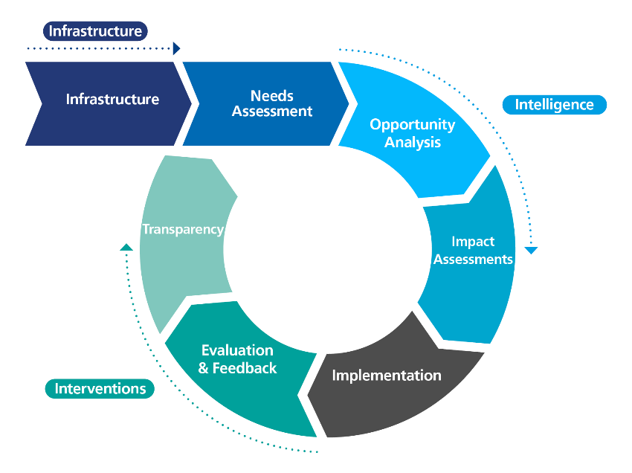This is a Population Health Management (PHM) approach which can help us create joined up and targeted services, improve the health and wellbeing of the population, enhance patient experience of care, reduce per capita cost of healthcare and improve productivity, increase the wellbeing and engagement of the workforce; and address health and care inequalities.

*Fig. 12: Population health management approach*

### *13.2.1* *Population health management*

Population health management is an intelligence driven approach which supports evidence-based decision making at all levels of an integrated care system. Its fundamental ingredients are linked data assets, system-wide analytical capabilities, widespread cultural adoption and leadership, a constant cyclical review of impact, system planning and evaluation.

A PHM approach applies to individual interactions, enabling care professionals and patients alike to access and link key information and identify more readily need, capacity to benefit and pathway eligibility (primary use) as well as to whole population analysis where it helps identify key factors like health needs, epidemiological trends, health inequalities and support evidence based strategic priority setting (secondary use).

### *13.2.2 Quality improvement*

### *Box 27: What is Quality Improvement (QI)?*

QI is about giving the people closest to issues the time, permission, skills and resources they need to innovate. It involves a systematic and coordinated approach to solving a problem using specific methods and tools with the aim of bringing about a measurable improvement. Quality Improvement draws on a wide variety of evidenced-based methods. It encourages an open, curious, and co-operative mindset in practitioners. It requires both technical and relational skills in how we work with others and build effective teams.

Our One Gloucestershire improvement community brings together partners from across health and social care to strengthen our collective improvement capability and capacity. Quality Improvement (QI) gives us powerful tools and techniques that optimise our work to improve health and wellbeing outcomes, join-up care and create best value in our service design. We have a great track record of QI enabling numerous projects that have delivered real benefits to people in Gloucestershire.  
As partners we are now facing many significant challenges and in a more interconnected world solutions are increasingly interdependent. This gives us more complex problems to solve, but more benefits to gain from innovation and collaboration. Working in partnership we are developing fresh approaches to how we support collaborative transformation and equip teams across our system to lead change together.

## **13.3 Our ambitions**

In order to support this approach, we need to ensure that we are collecting and linking good quality data and intelligence efficiently and consistently, and wherever possible supporting joined up records, avoiding the need for people to keep repeating their story to professionals. This will make our data assets more usable for the system, for clinicians and commissioners as well as improving people’s experience: Healthwatch consulted our communities in the preparation of the Long-Term Plan in 2020 and people reported wanting to have more joined up care records, and more individualised care, with appropriate resources in terms of language and accessibility.

We want to create space for innovation, supporting improvement based on both qualitative and quantitative data and recognising the value and challenge of the ‘ripple effect’ of our partnership. We will continue to develop our quality improvement approaches to enable more teams from across our system to play an active role in addressing the complex to social challenges we face, to develop a thriving improvement culture across Gloucestershire that energises teams to deliver system wide change and integrates an improvement mindset into how we work together every day.

As a system, we aim to champion evaluation and encourage the evaluation works toolkit and 5-step process (<http://www.nhsevaluationtoolkit.net/>) in the assessment of our projects. We are also committed to supporting research so that Gloucestershire can benefit from the latest developments across health and social care.

We know that research active health and care systems deliver better outcomes for patients and populations. It is our responsibility and commitment to the patients and public we serve in Gloucestershire to create a vibrant, flourishing research community to promote knowledge exchange and increase our impact regionally, nationally and internationally. We have established a local organisation to champion research: Research 4 Gloucestershire (R4G). R4G brings together partners in Health and Social Care and the University of Gloucestershire around the common aim to develop and support research for the benefit of patients, carers, staff and our population.

|  |  |
| --- | --- |
| **In 12 months, we will see:**   * Social care and healthcare data are linked and developed into intelligence to predict health outcomes, identify inequalities, and used to design care interventions and clinical pathways. * A comprehensive stocktake of analytical capabilities within the system has taken place with an associated development plan agreed. * Partners are systematically collecting information which will enable identification of inequalities in access, experience, or outcomes to tailor services accordingly. These includes information about ethnicity and communication needs. * Good examples of facilitated integration of quality improvement to support some of our systems most challenging priorities. | **In 5 years, we will see:**   * A system wide linked dataset (including social care, children and VCSE data) which is accessible to system partners alongside qualitative and engagement products. * Routine use of this linked data, and derived intelligence products including dashboards, across clinical pathways, strategic and locality planning and working, evaluation and within academic communities like Research for Gloucestershire (with use of advanced approaches e.g. machine learning where appropriate) * The required analytical and digital architecture, data assets, tools and capabilities across the system to embed Population Health Management, quality improvement and evaluation as business as usual across the system. This includes access to timely, linked data by those planning and/or evaluating services. * A thriving improvement culture across One Gloucestershire that has enabled teams from across our partners to deliver system wide change |

**14.1 The case for change**

# **Digitally enabled services**

The last two years have introduced us all to a greater use of technology than ever before, and we are determined to harness its potential to improve and join up care for our population. Our system partners have embraced new technologies faster, and adapted to provide support in different ways, to meet the needs of local people. Our digital approach seeks to provide simplicity for every citizen when connecting to health and care services across the county. Delivery of digitally enabled services is underpinned by our Data and Digital Transformation Plan, delivering platforms that are secure and trusted by our people and our care professionals.

*Fig 13: High risk areas for digital exclusion in Gloucestershire*

Whilst harnessing digital opportunities can bring significant benefits to our system, for a range of groups digital exclusion is a significant issue across Gloucestershire (Fig 13)[6]. This exclusion comes at a great cost –to the communities who are cut off; to the county getting left behind by better connected places; and a tangible cost to individuals who are paying higher bills than those who are on-line, find it harder to book health appointments or make benefit applications and miss out on potential connections.

Digital inclusivity was a key area highlighted during engagement with partners across Gloucestershire when discussing digitally enabled services. Other key areas were trialling and identifying new digital technology to solve issues and using analytics and technological opportunities to innovate.

Our digital approach seeks to address these challenges and opportunities whilst supporting our net zero ambitions across the county and providing a digital environment that encourages research and lifelong learning. We aim to strengthen our integration with partner organisations, local authority, and the voluntary sector to use digital enablers to better support citizens in their homes as well as in our care facilities.

## **4.2 How we are already creating change?**

Usage of digital tools by citizens has increased significantly since COVID-19, for example approximately 54% of adults in Gloucestershire now have access to the NHS app. This enables them to view their health record, order prescriptions, book appointments and view their COVID-19 vaccination status. National guidance aims to digitise services, connect them, and drive transformation. In practice this means:

* better outcomes and experience for people - a more personalised experience, new ways of accessing care and helping them stay healthy
* better experience for staff - information available for use by staff and citizens, reducing the time spent chasing referrals or test results, and staff can work more flexibly

*Box 28: Gloucestershire’s shared care record system, Joining Up Your information (JUYI)* has been in use across the county since 2018. JUYI shares information about patients from health and social care systems for direct care

* 500,000+ records have been accessed by clinicians since launch!
* New data feeds all the time. About to include Ambulance, Adult Social Care, IAPTUS. Patient Tracker.
* Branching out to within Care homes, hospices
* more effective population health management - ICSs understand the needs of their populations, and reshape their services to meet them

*“Since we’ve used JUYI, I've not asked for a clinical summary”.*

*“It's really helped with linking up all sorts of information from GP surgeries. We can look at it straight away and find a range of different things – medication, physical health.”*

These aims are key priorities within our digital and partnerstrategies. We want to ensure that our citizens and colleagues have access to the tools that they need, wherever they need them. We want to ensure that we are ‘digitally inclusive’.

## **14.3 Our ambitions**

We have identified **five key themes** to articulate our approach to delivering the digital strategy. These are summarised below:

* Our digital strategy is integral in driving our health and care future, demonstrating our commitment to change through citizen and staff engagement, robust planning and prioritisation
* We will invest in a people-first, needs led change management approach to ensure successful delivery
* Delivery Framework

1. Levelling Up

* All partners will move forward in digital maturity as one, ensuring no partner is left behind and all partners share in digital maturity increases and digital skills uplift.
* We will invest in a digitally inclusive community, ensuring equal access and connectivity to digital solutions
* We will build the infrastructure, systems, and digital tools to enable appropriate information to be shared in real-time to enable collaborative working and decision making, whilst improving planning and evaluation of services

3. Data & Information Sharing

* We will maximise the implementation of digital tools, products and services by changing our models of care, workforce and citizen engagement to continue to meet our citizens needs

4. Innovation and Growth

* PHM tools will give us insights into our population that will support clinical decision making and inform interventions

5. Population Health Management

## *Graphical user interface, application Description automatically generatedSimplicity for the citizen - Delivering digital for the population of Gloucestershire*

*Fig. 14: Delivering digital*

In delivering digital for the population of Gloucestershire**,** we will ensure that our solutions are simple to use by citizens and support them to have more control over their health and care, to be comfortable in using technology and data to manage their health throughout their lives, promoting healthy living and manage long term conditions where required. We will address digital exclusionacross the county, enabling our citizens to develop digital skills, not only for health and care assistance but to improve modern social/digital inclusion, especially with our most vulnerable groups.Facilitating independence of care to citizens through digital services. Supporting our digital journey we will have in place the necessary infrastructure, robust governance standards, cyber security and services to deliver safe, modern health and care services. Data capture and linkage will help us plan our resources and support clinical decision making. Through this we will deliver inclusive services, reducing variation and enhancing safety within our ICS.

|  |  |
| --- | --- |
| **In 12 months,** **we will see**   * The people of Gloucestershire will digital services available that they value, and are simple, trusted and engaging. * Staff in Gloucestershire are able to access their clinical systems at any time, in any place, reducing frustration of sourcing information * A sustainable system with technology enabled care targeted at key cohorts of need, reducing costs, workforce constraints and/or demand | **In 5 years, we will see**   * The people of Gloucestershire will have improved access and confidence in using digital tools and enhancing ability to be an active participant in managing their own health * Staff in Gloucestershire will have consistent access to relevant information, digital tools and technology enabled care targeted for key services across health and care, enhancing care planning * A sustainable system with implementation of the infrastructure required to prioritise population health prevention, improving outcomes and reducing costs of escalating health and care conditions (population heath management) |

# **15 Our call to action: Unifying Themes**

We are operating in a complex system and recognise that no one organisation can achieve the changes we seek. Making Gloucestershire the healthiest place to live and work, championing equity in life chances and the best health and care outcomes for all cannot be achieved in a simple linear fashion but requires an understanding of the interactions between multiple different elements of our system. Working together as equal partners is vital not only to achieve our vision but to acknowledge and respond to how different part of the system can indirectly, or directly, impact each other.

*Box 29: Key principles for selecting the unifying themes*

* Has a clear case for change
* Enables all partners to be able to demonstrate a contribution
* Operates across the whole life course from pre-birth to aging well
* Takes a preventative approach
* Has the ability to impact on health equity

Working within complex systems can seem overwhelming, however Myron Rogers, a leading author in complex systems provides some simple principles[7]. One of these is **“Start anywhere, follow everywhere”.** Following this principle, we have selected unifying themes help us test the opportunities and approach to working together as One Gloucestershire Health and Wellbeing Partnership. Whilst the themes we’ve selected are based on some key principles (see box 30), many different themes may have been suitable. However, this is less about what the unifying themes are and more about using them as a litmus test for the strategy and partnership. **Our call to action is to work together to make a positive impact on these unifying themes**. Working on these themes will provide us with important insights over the next year into how we can galvanise our collective effort to support the delivery of this strategy. We will use the knowledge we gain by working together to develop the next iteration of the Integrated Care Strategy. For each theme an ambition statement has been incorporated, we will work together over the coming months to identify what each partner can contribute towards achieving these ambitions, the scale of the impact we can collectively commit to, and the indicators we will use to understand our progress. In addition, an anchor organisation approach will further be developed in 2023 to support the delivery of these unifying themes. For 2023, the One Gloucestershire Health and Wellbeing Partnership (GHWP) three unifying themes are:

**Theme 3: Blood pressure**

* High blood pressure rarely has symptoms and so detection is opportunistic.
* Around a third of adults in the UK have high blood pressure, although many don’t know. In Gloucestershire we have identified 60.9% of the anticipated cases.
* Hypertension and the effects are a major cause of disability adjusted life years in the UK.
* Effective treatment of hypertension reduces the risk of heart attacks, stroke, heart failure and death.

**Ambition: Increase prevention and early identification of high blood pressure and support those with a diagnosis to manage their blood pressure**

.

**Theme 2: Smoking**

* Smoking is the single biggest cause of inequality in premature death rates and the leading cause of preventable disease and disability
* 50% of long-term smokers will die prematurely - many more live with debilitating illnesses
* Higher smoking prevalence is associated with almost every indicator of deprivation or marginalisation. In Gloucestershire:
* Smoking prevalence in adults – 11.6%
* Routine and manual workers – 26%
* Smoking prevalence in adults with a serious mental illness – 38%
* Smoking status at time of delivery - 11%

**Ambition: Identify greater numbers of smokers and signpost to appropriate smoking cessation support**

**Theme 1: Employment**

* In Gloucestershire, 8,550 people aged 16 to 64 are currently unemployed.
* 79% of people claiming Employment Support Allowance have been claiming for over 5 years
* 13,254 people are claiming Universal Credit with no work requirement this is more than double the figure in February 2020 (6,020) with significant increases in all age groups 20+
* 444 young people aged 16-18 are not in education, employment or training (NEET)
* Disabled people are twice as likely to be unemployed.

**Ambition: Create additional employment and skills development opportunities**

**16. Next steps**

**16.1 Creating change**

This strategy will set the blueprint for how our health and care organisations, staff, voluntary and community sector, and our people and communities, can work together to achieve the common goal of making Gloucestershire the healthiest place to live and work, championing equity in life chances and the best health and care outcomes for all. We will work together as partners to deliver the ‘in 12 months’ and ‘in 5 years’ commitments detailed throughout this document as well as the ambitions identified within the unifying themes.

All partners will be asked to explore what they can contribute to the delivery of this strategy, these contributions will be captured in a high level GHWP delivery plan, where we will monitor our progress and where necessary to challenge each other to do better. However, we recognise the need to remain agile and to respond to changes in our system, therefore the GHWP will seek to support and not stifle innovation and action.

**16.2 Understanding impact**

It is important to understand if we are making progress towards delivery of our ambitions and ultimately our vision. To define and measure positive progress we first must understand what we value. Once we understand this, we can explore whether we are adding value through our work, and ultimately how to measure and evaluate that.

We will develop a set of quantitative high-level indicators to monitor progress against each pillar, condition for change and unifying theme. However, we recognise that this is only part of the picture. We seek to use other methods of capturing the cumulative ‘ripple effect’ of the partnership as well as developing proxy indicators and capturing qualitative intelligence, including individual stories to understand the full intended and unintended effects.

**16.3 Learning and iteration**

As we move towards becoming a ‘learning’ system rather than a ‘solutions based’ system, we understand that this strategy is not a static document. We are committed to exploring people’s experiences and reflections on how we are working together to help us to further develop our partnership approach. As the partnership grows, we will iterate this Integrated Care Strategy to ensure it continues to pave the way for partners, communities and individuals to work collaboratively to make Gloucestershire the healthiest place to live and work, championing equity in life chances and the best health and care outcomes for all.

1. Source: [Public Health Outcomes Framework](https://fingertips.phe.org.uk/profile/public-health-outcomes-framework/data#page/1/gid/1000049/pat/6/ati/402/are/E10000013/iid/90362/age/1/sex/1/cat/-1/ctp/-1/yrr/3/cid/4/tbm/1) 
2. **Lower-layer Super Output Areas (or LSOA for short):** small areas designed to be of a similar population size, with an average of approximately 1,500 residents or 650 households.
3. [Place-based approaches for reducing health inequalities: main report - GOV.UK (www.gov.uk)](https://www.gov.uk/government/publications/health-inequalities-place-based-approaches-to-reduce-inequalities/place-based-approaches-for-reducing-health-inequalities-main-report)
4. [JSNA Gloucestershire 2022](https://www.gloucestershire.gov.uk/media/2118477/jsna_infographic_2022_mental-wellbeing_final.pdf)
5. Development and validation of an electronic frailty index using routine primary care electronic health record data, Age and Ageing, Volume 45, Issue 3, May 2016
6. Source: [Digital Divide](https://static1.squarespace.com/static/617abf9b742ed51f29193232/t/62443af43d9fc81d2d9a14e4/1648638711164/Digital+Divides+Report.pdf)
7. # M. Wheatley & M. Rogers, A Simpler Way (2012)

  